Talk with field researchers about their work on:
Climate Change at the Land-Sea Interface

Tuesday, October 13, 11am-12pm PDT/2pm-3pm EDT
Register Here for a Zoom link

Bring researchers into your classroom and give students a window into the process of scientific inquiry. Join us for an informal chat with researchers studying how climate change is affecting the rocky intertidal zone in California, Maine, and Oregon. Find out who they are, how they got interested in this habitat, and the research questions they are asking. Instructor’s guide available.

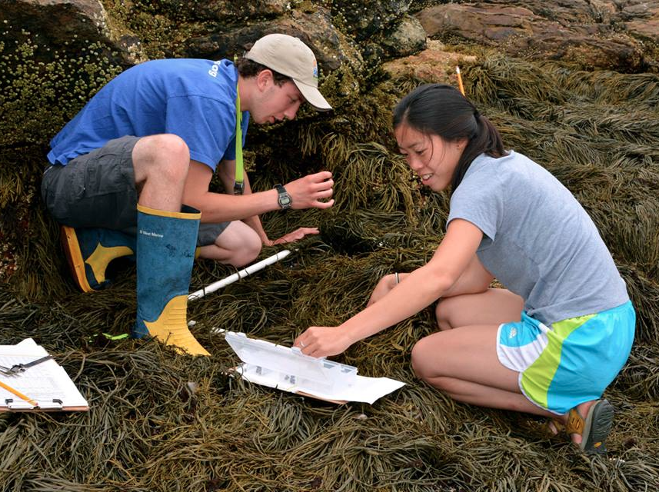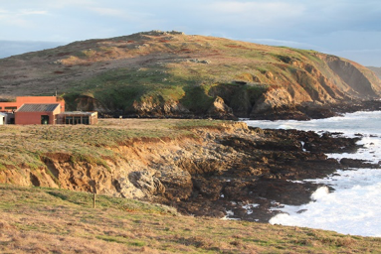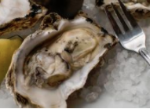

Moderated by: Jarrett Byrnes, Assistant Professor, University of Massachusetts
Boston and Shoals Marine Laboratory Faculty

Bodega Marine Reserve, UC Davis Eric Sanford, Professor of Biological Sciences Species on the move: Impacts of a changing ocean on coastal CA

Hatfield Marine Science Center, Sarah Gravem, Research Associate, Partnership for Interdisciplinary
Oregon State University Studies of Coastal Oceans (PISCO)
Effects of climate change on Pacific Northwest intertidal communities

Shoals Marine Laboratory, Cornell Jennifer Dijkstra, Research Assistant Professor, UNH School of
University & University of New Marine Science and Ocean Engineering
Hampshire Drivers and implications of seascape change in the Gulf of Maine

“Live from the Field” events are part of the Organization of Biological Field Stations (OBFS) The Virtual Field (thevirtualfield.org), an international collaboration prompted by the pandemic to give students virtual field experiences in ecosystems all over the world. Events are informal and recorded for asynchronous instructional use. All are welcome. For more information: Dr. Claudia Luke, Sonoma State University, lukec@sonoma.edu

