Statistics Unit

Exit Tickets
NAME:  DATE:  - Find the mean, median and mode of the data set:  20, 32, 24, 40, 24, 28  - Give an example of a data set with more than one mode.  - What is the range of the data set?  82, 77, 85, 92, 89, 99, 79, 85 | Work space: | Responses:  - Mean:  Median:  Mode:  - Range:

NAME:  DATE:  - Draw a dot plot of the following data set:  8, 6, 10, 10, 9, 8, 4, 10, 8, 10, 9, 7  - What percent of the values are greater than or equal to 8? | Responses:

NAME:  DATE:  Use the histogram to answer the following questions:  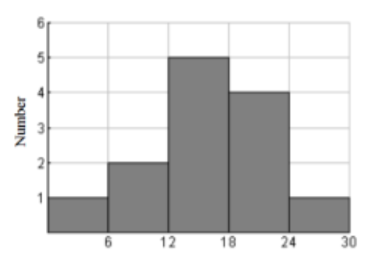 | Responses:  - What is the interval width?  - Which interval has the most values?  - How many values are in the data set?  - How many values are 18 or higher?  - In which interval would the number 12 be included?

NAME:  DATE:  - Create a box and whisker plot for the following data set:  62, 72, 73, 78, 78, 84, 86, 91, 95, 95, 98  Use the box and whisker plot to answer the following questions:  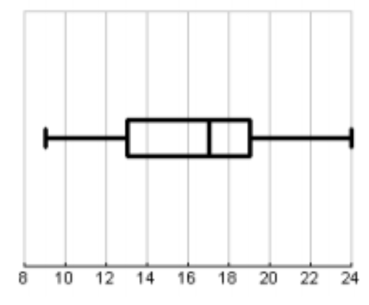 | Responses:  11.  - What percent of the values are greater than 17?  - About 25% of the values are less than ___________.  - About __________% of the values are greater than 19.

