Human Impact Management Plan Evaluation Considerations & Rubric
EQ: How can we design a system to monitor human effects on a natural habitat?

From NGSS: “The performance expectations in ESS3: Earth and Human Activity help students formulate an answer to questions such as: “How is the availability of needed natural resources related to naturally occurring processes, How can natural hazards be predicted, How do human activities affect Earth systems, How do we know our global climate is changing?” The ESS3 Disciplinary Core Idea from the NRC Framework is broken down into four sub-ideas: natural resources, natural hazards, human impact on Earth systems, and global climate change. Students understand the ways that human activities impact Earth’s other systems. Students use many different practices to understand the significant and complex issues surrounding human uses of land, energy, mineral, and water resources and the resulting impacts of their development. The crosscutting concepts of patterns, cause and effect, and stability and change are called out as organizing concepts for these disciplinary core ideas. In the ESS3 performance expectations, students are expected to demonstrate proficiency in asking questions, developing and using models, analyzing and interpreting data, constructing explanations and designing solutions and engaging in argument; and to use these practices to demonstrate understanding of the core ideas.”

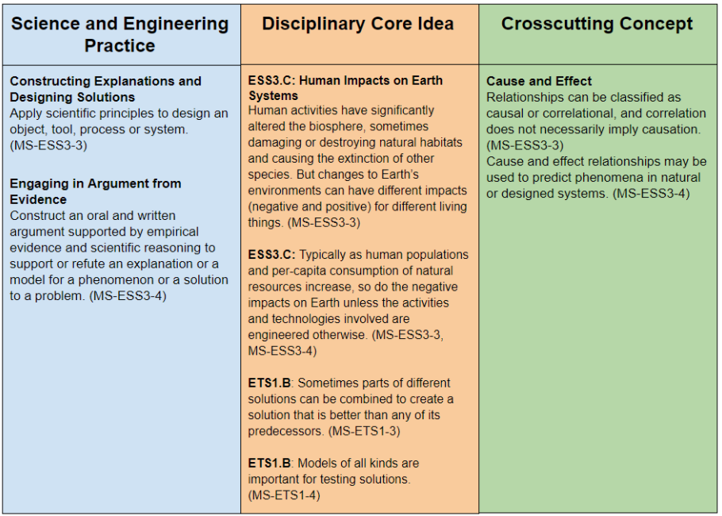

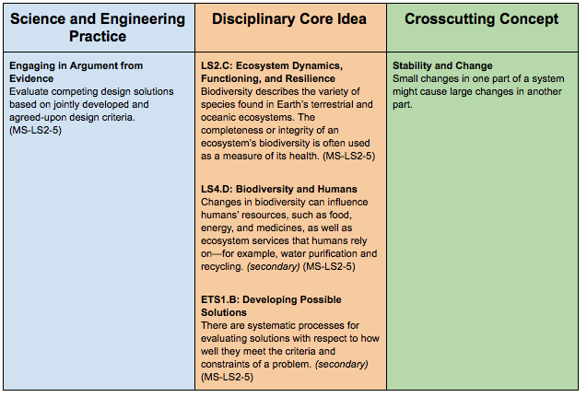

Project aspect | Exceeding the performance expectation | Meeting the performance expectation | Approaching the performance expectation | Not meeting the performance expectation
Describes the ecosystem & biodiversity. | Thoroughly & accurately describes the ecosystem’s biodiversity; includes thoughts on the health of the ecosystem. | Includes a straightforward description of the ecosystem’s biodiversity. | Attempts a description of the ecosystem; may not be thorough or complete. | Does not include ecosystem description or description is totally inaccurate.
Describes how humans interact with the ecosystem. | Thoughtfully and thoroughly describes both positive and negative human impacts on the ecosystem. | Provides a succinct, accurate description of how humans interact with the environment. | Description of human impacts is attempted but may have inaccuracies or may lack breadth. | Human interaction section is missing or not relevant.
Provides a method of measuring and monitoring the impact of human interactions with the ecosystem. | Proposed system is practical and effective, including a way to gather data and visuals. Possible constraints are identified and analyzed, and potential impacts are addressed. | Proposed system is plausible and includes a data gathering tool. Some constraints or potential for negative impact are addressed. | An attempt or idea is formulated but may not be realistic or complete. | Monitoring system is very underdeveloped or missing.

