Teeming with Fish: Building Background

Vocabulary

Vocabulary Notes
*Teacher notes: You can use these vocabulary cards for direct instruction (3-column notes) or print & cut to create a Memory or Go Fish game or other vocabulary game of your choice.

WORD | MEANS | VISUAL
BIODIVERSITY | the variety of life in the world or in a particular habitat or ecosystem. | 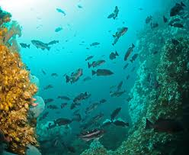
HABITAT | The place where an organism naturally lives & grows | 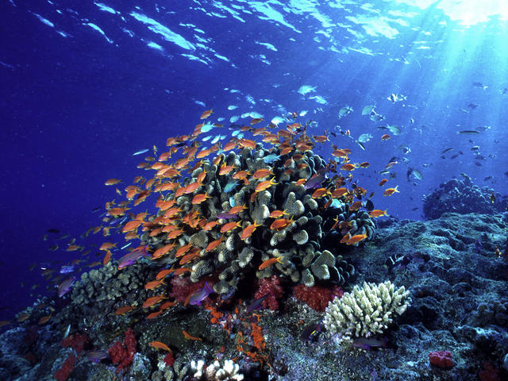
POPULATION | A group of interacting individuals of the same species located in the same area | 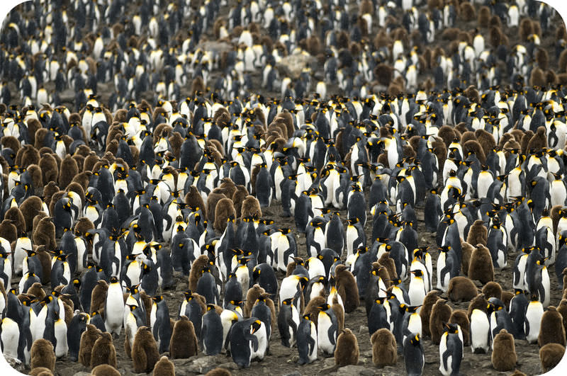
FISHERY | a fishing ground or area where fish are caught; the occupation or industry of catching or rearing fish. | 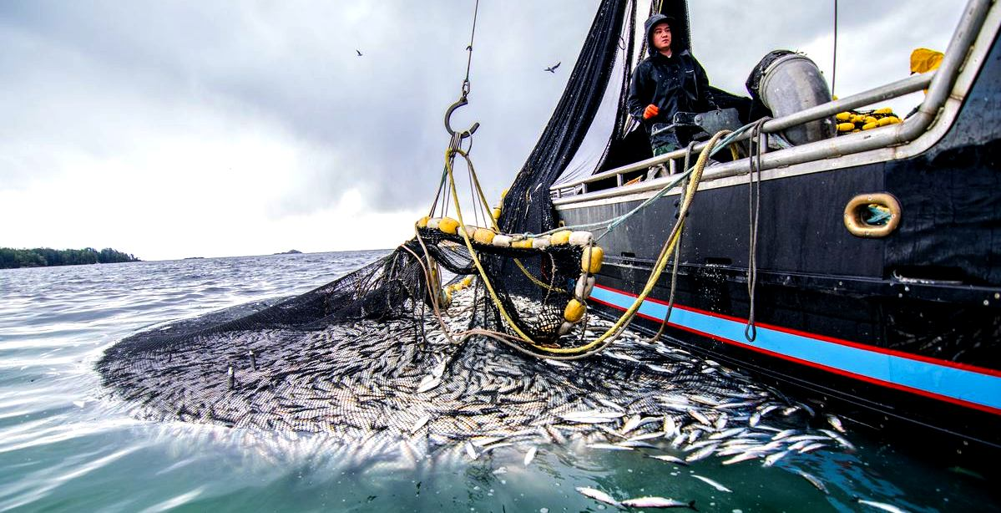
SUSTAINABLE | conserving an ecological balance by avoiding depletion of natural resources.
DATA | facts and statistics collected together for reference or analysis. | 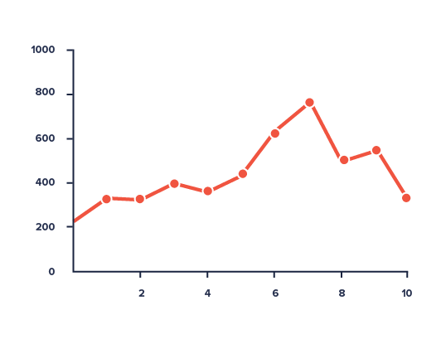
VARIABILITY | amount of spread of the scores around the mean. | 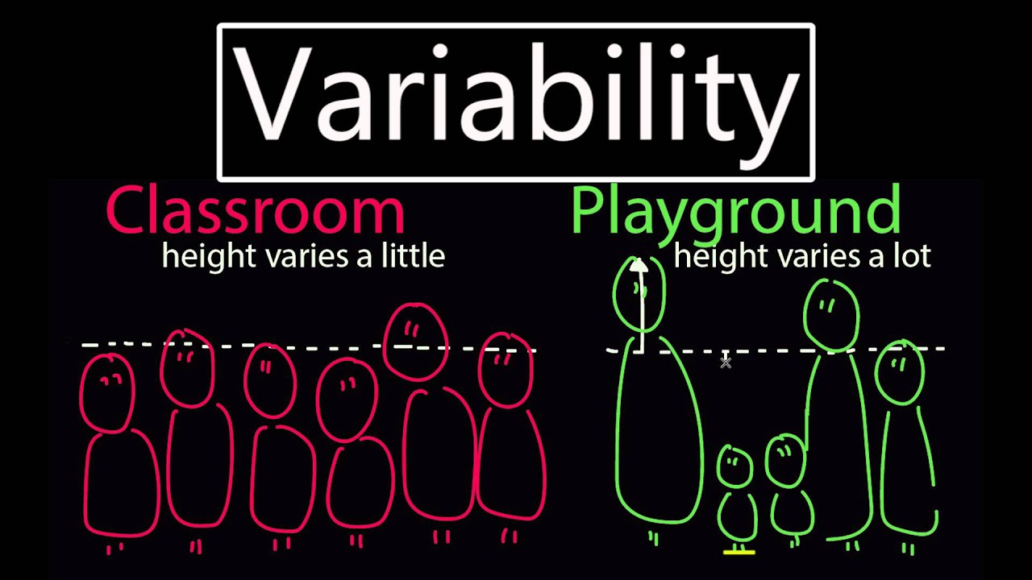
MEAN | An average; the value obtained by dividing the sum of several quantities by their number | 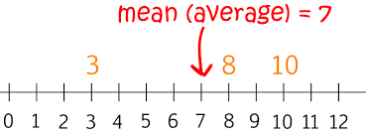
MEDIAN | The "middle" of a sorted list of numbers. | 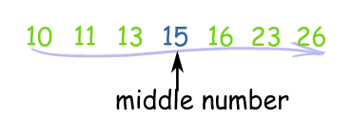
MODE | the value that occurs most frequently in a given set of data | 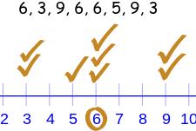
RATIO | proportional | 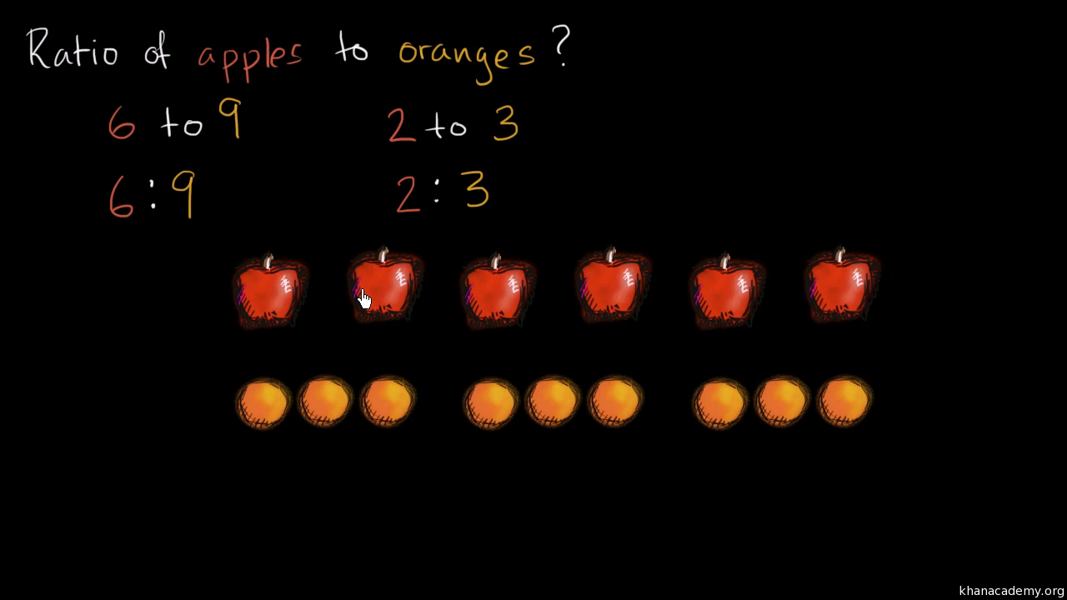
COMMERCIAL (fishing) | the activity of catching fish and other seafood for profit | 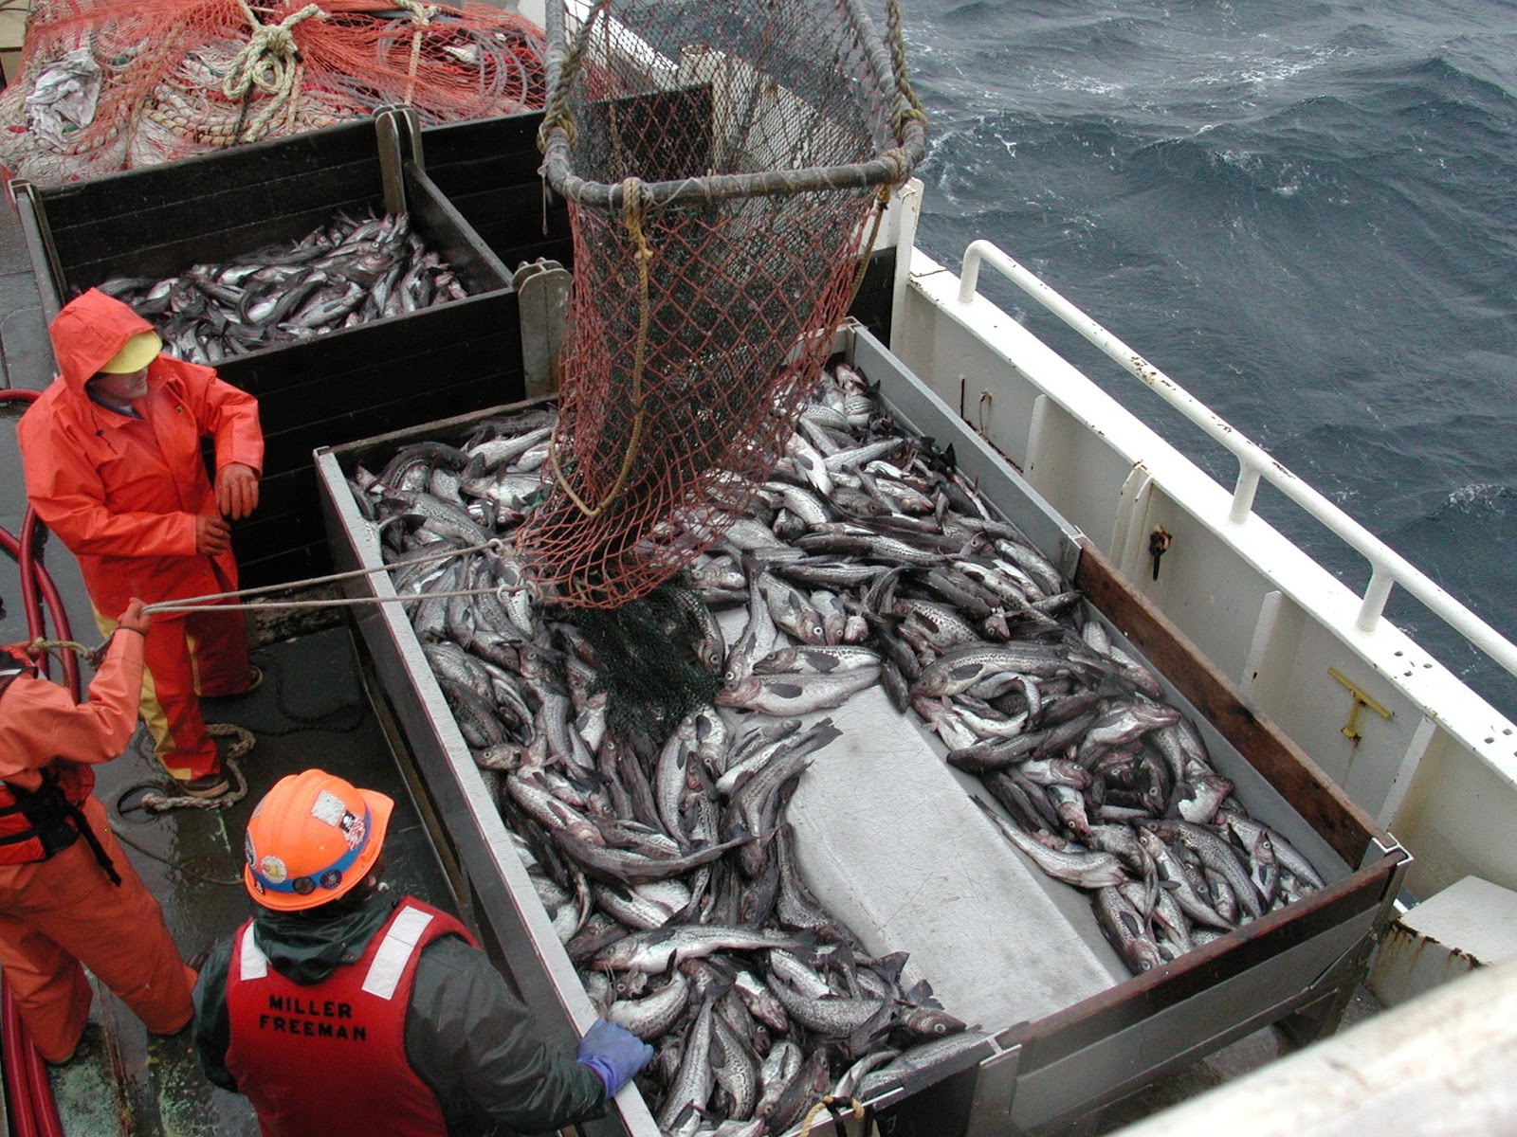
RECREATIONAL (fishing) | also called sport fishing, is fishing for pleasure or competition | 