Copepod Conundrum – Guided Notes #2
By Sara Pursel and Samantha Zeman

Examine the Stop Light Table below an answer the following questions.

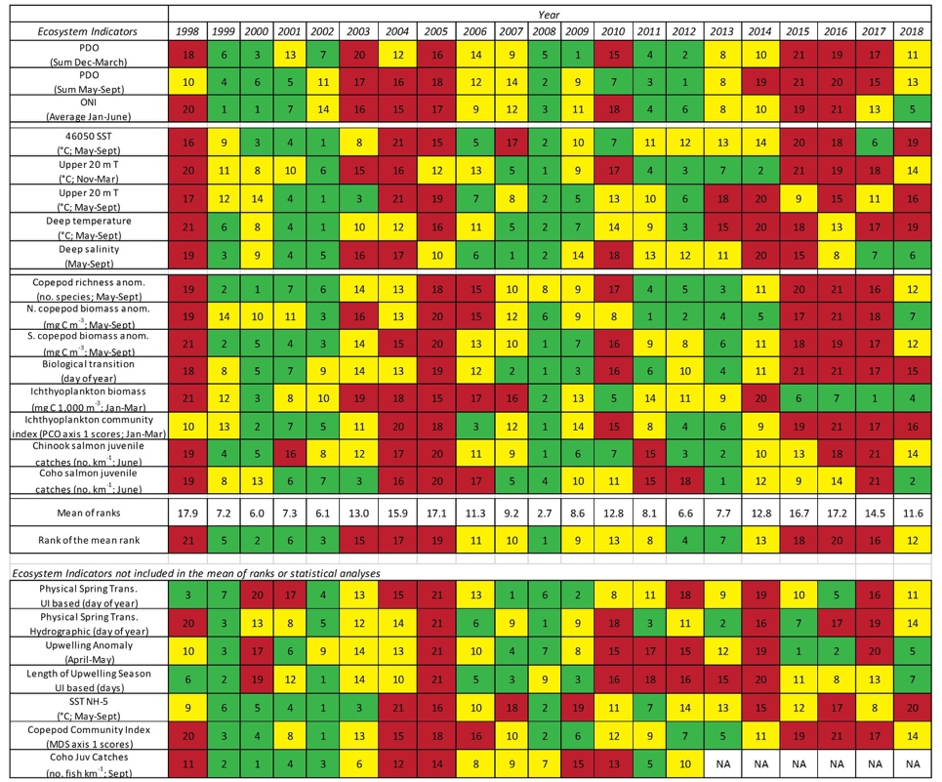

- Why is this called a Stop Light Table?

- What patterns or trends do you see in the data?
Please go to this link to help answer the next questions.
- What do the colors in the table represent?
- What do the numbers in the squares indicate?
- Which types of copepod data appear to be “good” indicators for salmon growth and survival, and why?

- How do the dataset your team graphed compare to the data presented in the Stop Light Table? Is there any overlap?

