Save the Cook Inlet Belugas Action Plan
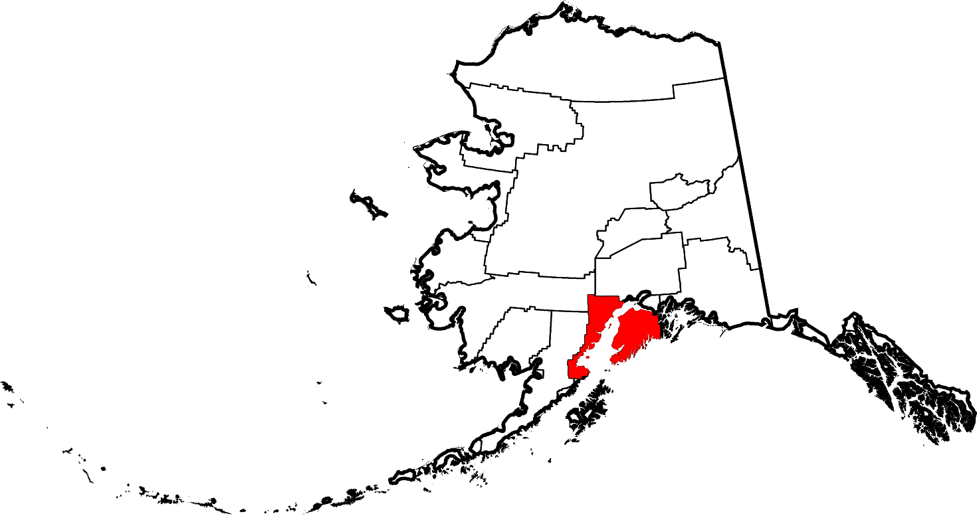

Overview
Now that you’ve had the opportunity to determine some of the common issues for the decline of the Cook Inlet beluga population, it’s time for you and your partners to develop a plan of action to help save this species.

Objectives
Your plan must include the following criteria:
- Demonstrate the scientific knowledge you’ve obtained through the resources provided.
- Select two or more strategies that are currently being used to decrease the decline in population and determine their effectiveness and address any areas needing improvement (how would you improve it?).
- Design an organized step by step plan of action.
- Implement an action plan.

Specifications & Assessment
Your plan of action must be something that can be implemented (even if not by you) and will motivate your peers and/or potential stakeholders.. You must utilize the resources provided as well as others you find via research. Make sure you cite all sources. You will need to present your plan to your peers using one of the following displays; poster, slide show, or video. If you have other ideas, let’s talk. You will be scored via rubric.

