Copepod Conundrum – Guided Notes
By Sara Pursel and Samantha Zeman

Please go to this link and after reading the article, answer the following questions:

- Draw and label a simple food chain showing the trophic relationship between copepods and juvenile salmon.

- What is the difference between warm-water and cold-water copepods? Where do they come from, and how do they impact salmon?
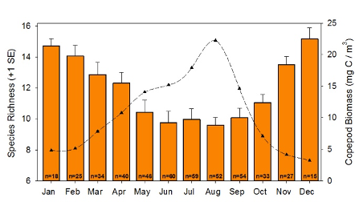
Examine the figure below showing seasonal changes in copepod biomass and biodiversity. Copepod biomass is indicated by the dashed line, and species richness is indicated by the bars.

- What pattern(s) do you see in the graph?

- Ask at least one question about the figure.

Please read about PDO described at this link and at this link, and then answer the following questions:

- What does PDO mean? Please explain, do not just write what it stands for.

- After looking at the information on the page, do you think PDO is a good indicator for salmon? Why or why not?

Please go to this link and answer the following questions about ONI:

- What does ONI mean? Please explain, do not just write what it stands for.
- After looking at the information on the page, what is one reason scientists use this as an indicator of ocean conditions?

Please go to this link and answer the following question on this article about ocean indicators.

- After looking at the information, describe your overall impression of the summary. Do you think these ocean indicators meant that it 2019 was a good environment or a poor environment for the ecosystem? Explain your thinking.

