Oregon Sea Pickle Invasion
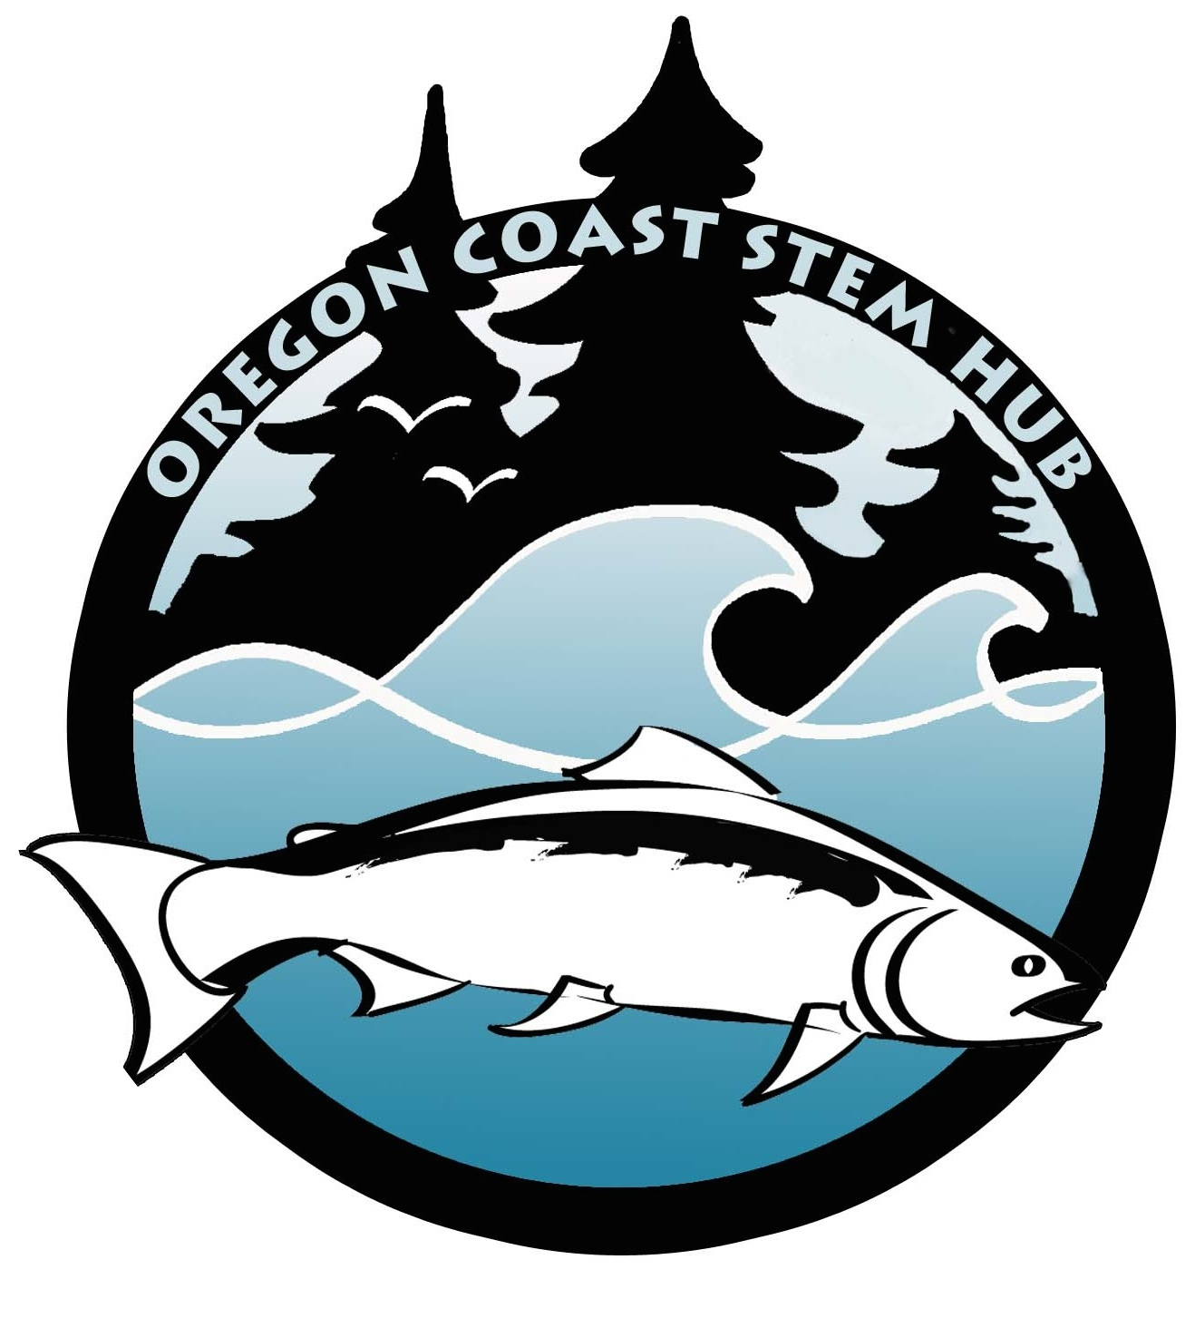
OVERVIEW
Since 2014, sightings of unusually high densities of pink, gelatinous, tube-like sea life have been reported off the Oregon coast, washing up on beaches and clogging fishing gear (Sorenson, 2017). Marine scientists are trying to understand the reasons for their sudden appearance. Could climate change be responsible?

GRADE LEVEL: 9 - 12

NGSS Disciplinary Core Ideas: LS1.A: Structure and Function; LS2.A: Interdependent Relationships in Ecosystems; LS2.C: Ecosystem Dynamics, Functioning, and Resilience; ESS2.D: Weather and Climate; ESS3.D: Global Climate Change.

NGSS Cross Cutting Concepts: Cause and Effect; Systems and System Models; Stability and Change; Structure and Function; Patterns.

NGSS Science and Engineering Practices: Asking Questions and Defining Problems; Analyzing and Interpreting Data; Constructing Explanations and Designing Solutions; Engaging in Argument from Evidence; Obtaining, Evaluating, and Communicating Information.
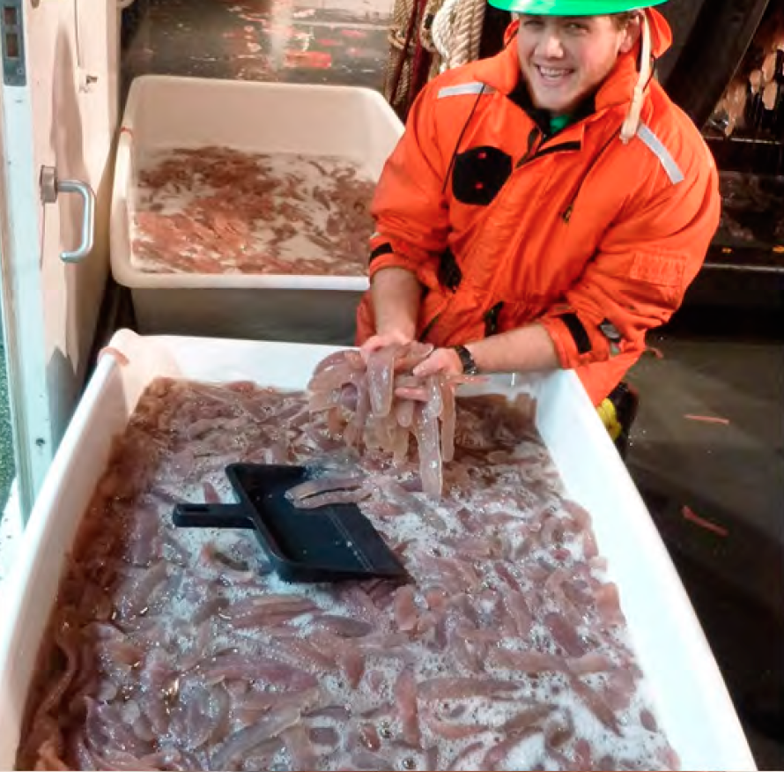 | 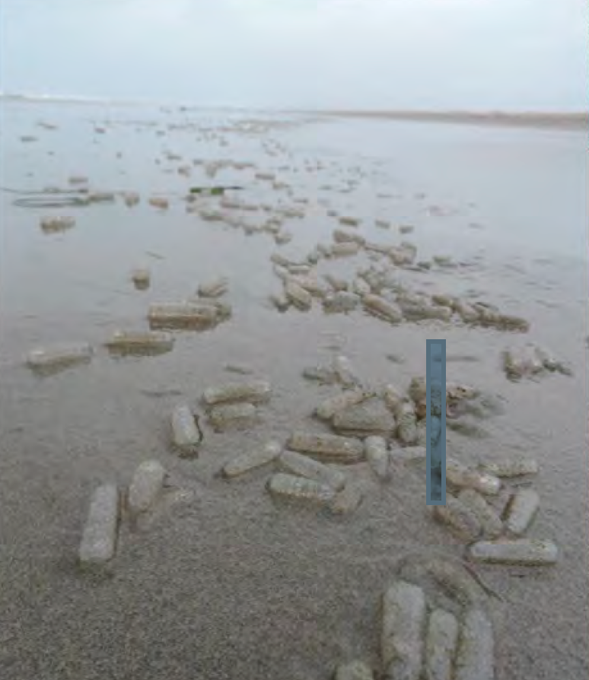
A large catch of pyrosomes from a pelagic survey off the Oregon coast, 2017 | Pyrosomes on an Oregon beach, 2017

INTRODUCING THE ANCHORING PHENOMENA

1. Begin class by sharing the two photos above without photo captions. (Photo credits: Brodeur, et al., 2018.)

2. Ask: Has anyone ever seen or heard of these? If so, encourage students to explain where and when they have observed them.

3. Depending on answers, explain/confirm that students are looking at photos of what are called pyrosomes (Pyrosoma atlanticum) taken along the Oregon coast in 2017.

4. Follow up this discussion by sharing the NOAA video footage of pyrosomes taken 85 miles off of Newport, Oregon to a depth of 100 meters. While watching, challenge students to record at least two observations about pyrosomes that could help them understand how they move or what they might eat and one question they now have about pyrosomes.

https://youtu.be/9ovWa83GIOo

5. Create a class list of observations and questions about pyrosomes.

EXPLORING THE ANCHORING PHENOMENA

The appearance of such high densities of a normally tropical sea life in the much colder Pacific has created many questions for marine scientists.
1. Share the four-minute video link below and challenge students to individually listen and record at least three questions marine scientists are now pursuing as a result of the unusual pyrosome sightings.
https://www.youtube.com/watch?time_continue=3&v=YLFbQpkrsBY

2. Split students into groups of three and complete a round robin where each student shares one of the questions they listed. As a whole class, record one research question from each group. Possible examples:
- Why are pyrosomes occurring in such high numbers on the Oregon coast?
- Where do they normally occur?
- Why are they occurring in such high densities?
- Why are they occurring now?
- What do pyrosomes eat?
- What eats them?
- What is the impact of so many pyrosomes on the Oregon coast?

EXPLAINING THE ANCHORING PHENOMENA

1. Share with students possible explanations being examined by marine scientists for the high density pyrosome sightings on the Oregon coast:

Pyrosomes are being delivered to coastal waters from farther offshore and southern waters because warmer ocean conditions from global climate change are creating an ideal environment for them to thrive.

The large El Nino event in 2016 brought high densities of pyrosomes. The pyrosomes are staying and reproducing even though conditions have returned to normal.
Beginning in 2014, an unusually warm and stable water mass termed the “blob” formed in the North Pacific and lasted several years. Pyrosomes arrived as a result of this phenomena.

2. Using the Oregon STEM partners, research articles, and resources listed below, challenge student teams to research which claim the scientific data most supports.
Each team will share their conclusions using the Claims, Evidence, and Reasoning strategy. Teams should also prepare a rebuttal that explains why the unselected or alternative claims are not the best descriptions for the pyrosome phenomena.
CLAIMS, EVIDENCE, REASONING AND REBUTTAL STRATEGY
Make a Claim: A statement that identifies which anchoring phenomena explanation the team agrees is most consistent with the scientific evidence.
Provide Evidence: Sufficient, appropriate, qualitative and/or quantitative evidence that supports their claim.
Share Reasoning: Explain how or why the data counts as evidence to support their claim, provide a justification for why this evidence is important to their claim, and include one or more scientific principles that are important to their claim and evidence.
Image Credit: Digital Chalkboard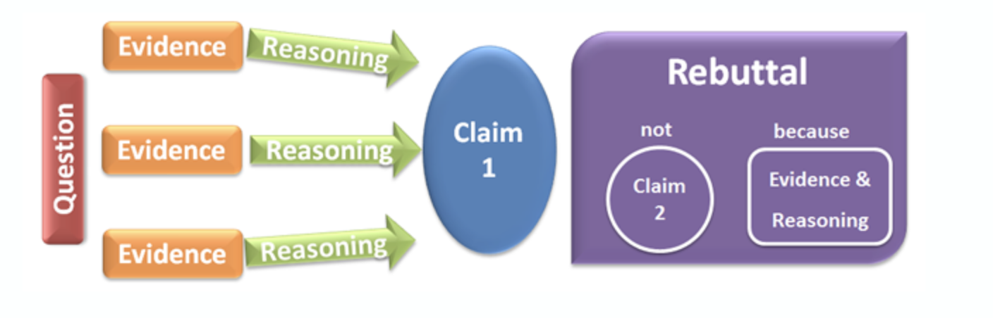
SUPPORTING RESOURCES

Oregon Partner Contacts:

Cooperative Institute for Marine Resource Studies
Oregon State University
Hatfield Marine Science Center
2030 Marine Science Drive
Newport, Oregon 97365
P: 541-867-0404

Dr. Kim Bernard, Assistant Professor
College of Earth, Ocean, and Atmospheric Sciences
Oregon State University
Corvallis, Oregon
P: 541-737-9337

Articles:
Brodeur, R., Perry, I., Boldt, J., Flostrand, L., Galbraith, King, J., M., Murphy, J., Sakuma, K., and Thompson, A. (2018). An unusual gelatinous plankton event in the NE Pacific: The great Pyrosome bloom of 2017. PICES Press, 26(1), 21-27.

https://www.researchgate.net/publication/322665037_An_unusual_gelatinous_plankton_event_in_the_NE_Pacific_The_Great_Pyrosome_Bloom_of_2017

Sutherland, K. R., H. L. Sorensen, O. N. Blondheim, R. D. Brodeur, A. Galloway. In press. Range expansion of tropical pyrosomes in the northeast Pacific Ocean. Ecology. 0(0), pp. 1-3.

Oregon Field Guide
https://www.opb.org/television/programs/ofg/segment/west-coast-oregon-pickle-shape-creature-pyrosome/

Northwest Fisheries Science Center
https://www.nwfsc.noaa.gov/news/features/pyrosomes/
https://www.nwfsc.noaa.gov/news/blogs/display_blogentry.cfm?blogid=1&month=06&year=2017#blogentry126

National Geographic
https://news.nationalgeographic.com/2017/06/pyrosome-fire-body-bloom-eastern-pacific-warm-water/

CLIMATE CHANGE RESOURCES

NASA Global Temperature Visualizer
https://climate.nasa.gov/interactives/climate-time-machine

Authors: Lisa M. Blank, Tracy Crews, Nancy Steinberg, Elizabeth Daly, Kama Almasi

