Statistical Salmon Analysis

Salmon Stats Student Worksheet #1

Analyzing a Line Graph

A line graph or line chart is a graphical representation of data points connected by short line segments. Line graphs are commonly used to track changes throughout time. In the following questions, you will investigate a line graph that shows changes in returning adult Coho salmon over the Willamette Falls on the Willamette River from 1965 to 2021.
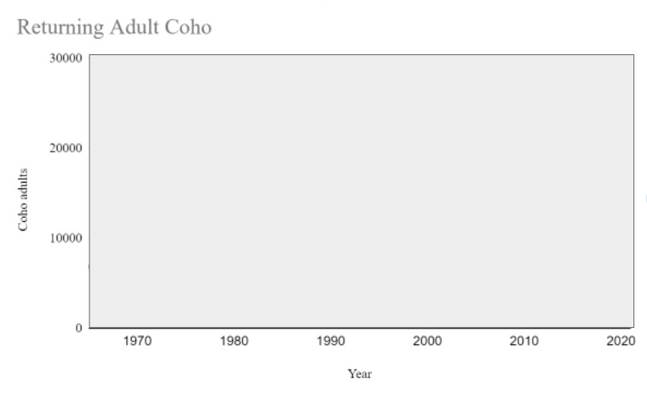
In the graph above, the data has been blocked out so we can focus on what the chart is telling us.
- What is the label on the x-axis? ______________
- What is the label on the y-axis? __________________
- What is the minimum value on the y-axis? _______________
- What is the maximum value on the y-axis? _______________
- What does this graph tell us about Coho salmon?

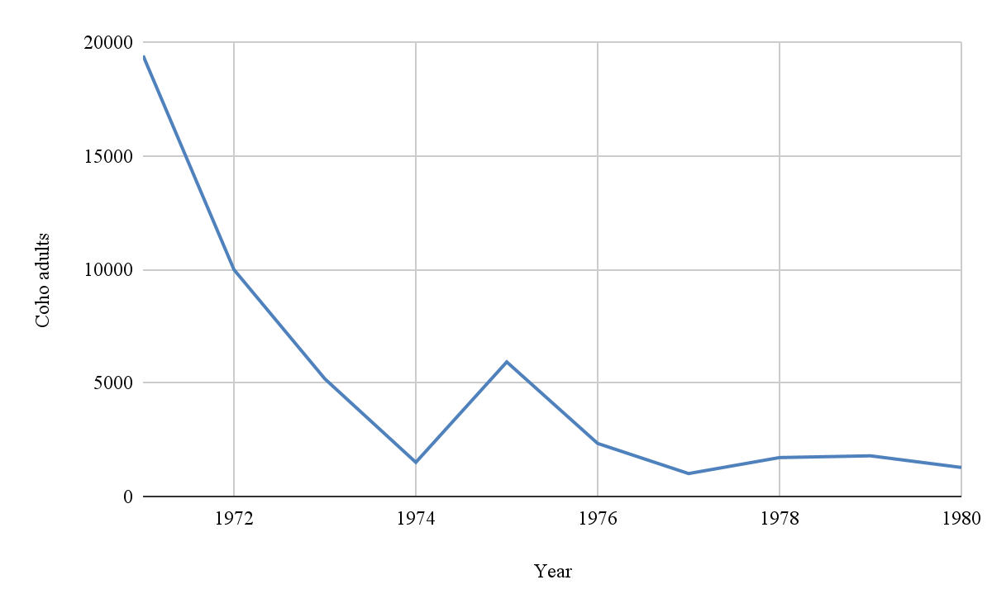
Use the graph above to answer the following questions.
- What do you notice about the number of adult Coho between 1971 and 1980?

- If you were a scientist studying this population of salmon, would you be concerned? Why or why not?

- Draw a line graph below predicting what the population graph will look like in the next ten years between 1980 and 1990.

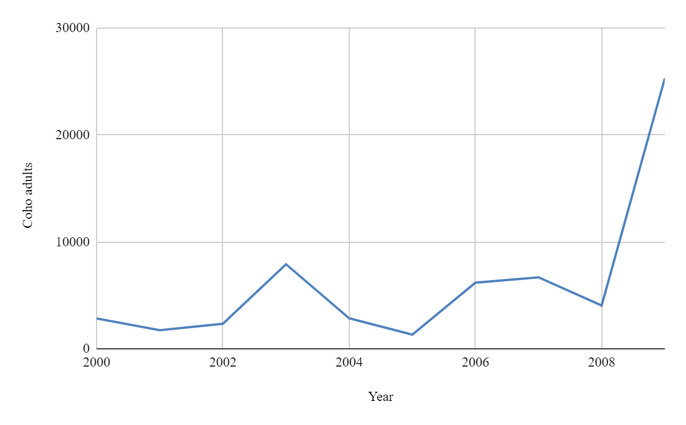
Use the graph above to answer the following questions:
- What do you notice about the number of adult Coho between 2000 and 2009?

- If you were a scientist, would you be concerned about the population after seeing this graph? Why or why not?

- Draw a line graph below predicting what the population graph will look like between 2010 and 2021.

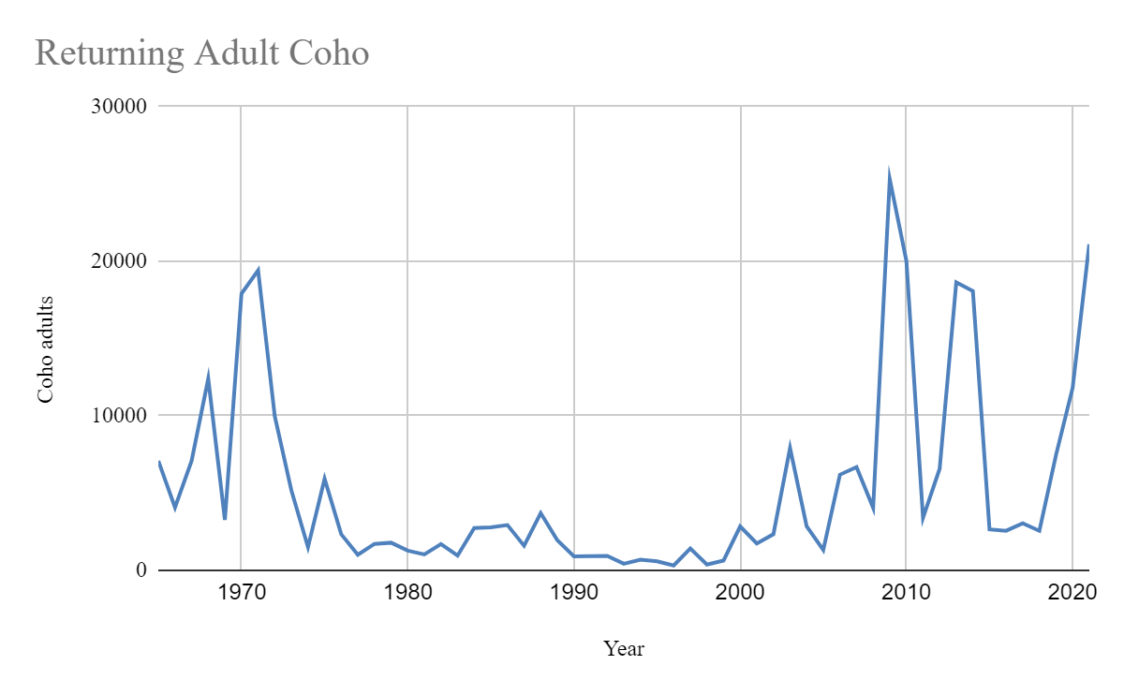
Use the graph above to answer the following questions.
- Did your predicted graph from question 8 match the graph between 1980 and 1990? If not, what was different?

- Did your predicted graph from question 11 match the graph between 2010 and 2021? If not, what was different?

- What kinds of patterns do you see on the graph?

- When considering management strategies for a population, why do you think it is important to look at a bigger window of time instead of a smaller window of time?

