Student Worksheet – Map Analysis

Forams as Storytellers

Which map are you analyzing? ___________

What do you notice about your map? Where are temperatures higher, average, or lower than average?

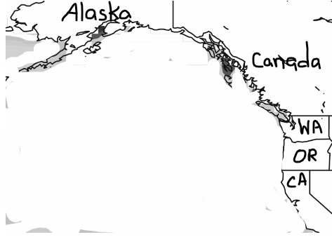
Vocabulary to use:
Anomaly (how is the measurement different from the average?)
Longitude (how far east or west is this location?)
SSTs (Sea Surface Temperatures) or
SSTas (Sea Surface Temperature anomalies)
Marine wildlife (animals that live in the ocean)
Marine plants (plants that live in the ocean)

What could happen to marine wildlife and plants in these areas?

