Dot Plots and Temperature

Student Packet (English)

Throughout this assignment, we will be trying to answer the following questions.
What is the average temperature in Antarctica?
Have these temperatures changed over time?

You will be provided with temperatures over a period of time. These temperatures have been collected from the scientific bases shown in the image below.

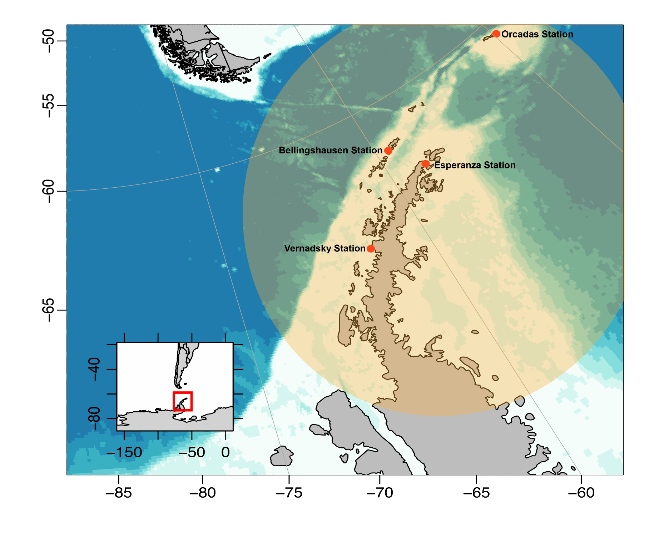

Year | Station | Avg Temperature ( C) | Avg Temperature (F)
1976 | Faraday | -5 | 23
1976 | Esperanza | -5.1 | 22.8
1976 | Orcadas | -3.2 | 26.2
1976 | Bellingshausen | -2.7 | 27.1
1996 | Faraday | -2.2 | 28
1996 | Esperanza | -4.2 | 24.4
1996 | Orcadas | -2.7 | 27.1
1996 | Bellingshausen | -1.3 | 29.7
2016 | Faraday | -2.9 | 26.9
2016 | Esperanza | -2.5 | 27.5
2016 | Orcadas | -3 | 26.6
2016 | Bellingshausen | -1.6 | 29.1

- What are the four different locations where this data was collected?

- Will four locations give us an accurate representation of the temperature in Antarctica? Why or why not? Why do you think you are only given four locations?

- Which year had the lowest average temperature? What was that temperature?

- Which year had the highest average temperature? What was that temperature?

- Before creating a dot plot or calculating the averages, do you believe that there has been a temperature change in Antarctica? Why or why not?

Create a Dot Plot of all temperatures given to us in Celsius

Create a Dot Plot of all the temperatures given to us in Fahrenheit

- Do you notice any clusters of data? (An interval with multiple data points)

Create a Dot Plot of the temperatures from 1976
(You may choose to do Celsius or Fahrenheit)

Create a Dot Plot of the temperatures from 1996
(You must use the same measurements as you did above)

Create a Dot Plot of the temperatures from 2016
(You must use the same measurements as you did above)

- Now that you have created several dot plots, visually, during what year do the temperatures appear to be the lowest? Which year appears to have the highest temperatures?

- What is the mean from every year? (Choose the same measurement as the dot plots from the previous page)

- What is the median from every year? (Choose the same measurement as the dot plots from the previous page)

- Based on the plots and the averages, do you believe that there has been a change in the temperature in Antarctica?

