Activity C: Open-Ended Graphing & Analysis

Kelp Forest Complexity

Now that you have spent some time in class considering biodiversity, species richness, and evenness, it’s time to do your own data analysis! You will need to open the Activity C Excel datasheet and save a copy of the spreadsheet to your files or Google Drive.

Work alone or in small groups to ask and answer your own research question. You will need to make a data table, calculate summary statistics, create a figure, and interpret that figure to draw conclusions. Feel free to use one of the example questions listed below or think of your own! This guide will help you follow the necessary steps to go from an ecological question to the answer.

Example questions:
- Is algal biodiversity related to flow rate?
- How does flow affect species richness?
- How does evenness change as we go deeper? How does depth affect other measures (biodiversity, richness)?
- What site has the highest diversity overall? What depth range has the highest diversity?

Step 1: The first part of our analysis will be to come up with our driving question.
For this exercise, your question should include both an independent (environmental) and dependent (measured) variable.
Using what you have learned, what we have in the datasheet, or one of the
example questions listed above, write your question here:

Now, write out your prediction. What answer do you think you’ll find?

Step 2: After deciding what variables you are interested in, list them below. These
will be the main components of your question and should be chosen from the column names in the Activity C Excel data datasheet.

Independent variable: _______________________

Dependent variable: _________________________

Step 3: Once you have decided on your variables it’s time to set up our data table!
Depending on the question, your data table will look different. You may be able to work with entire columns, or you may need to take averages and prepare your data a bit more. Here are some examples of what a data table might look like.

- For the question “Is diversity higher in low flow or high flow areas?”:
In this case, the table is very small since we are just looking at an average over several sample plots. The average is calculated by using the formula =AVERAGE() and selecting all of the Diversity cells that have either “high” or “low” as their Flow value.
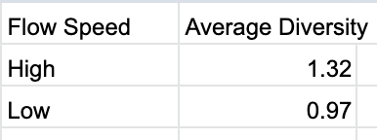
For the question “Is there a relationship between depth and evenness?”, we are interested in looking at the entire dataset for our graphs. Here, we can use the whole columns.
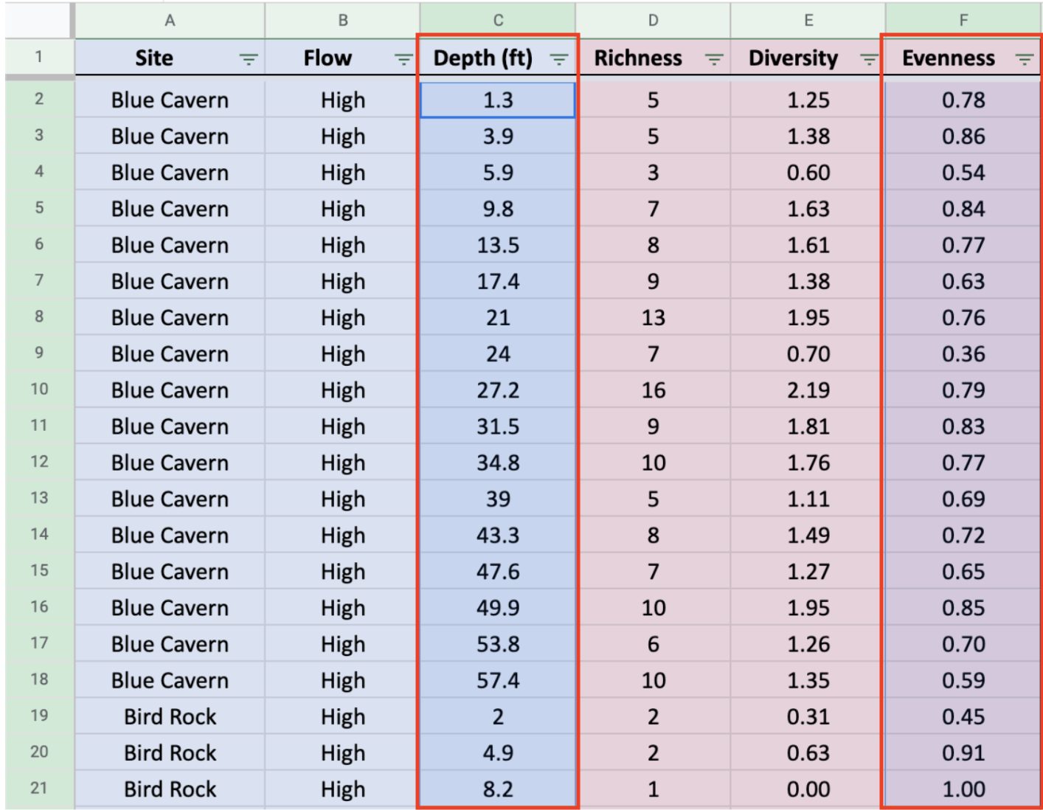
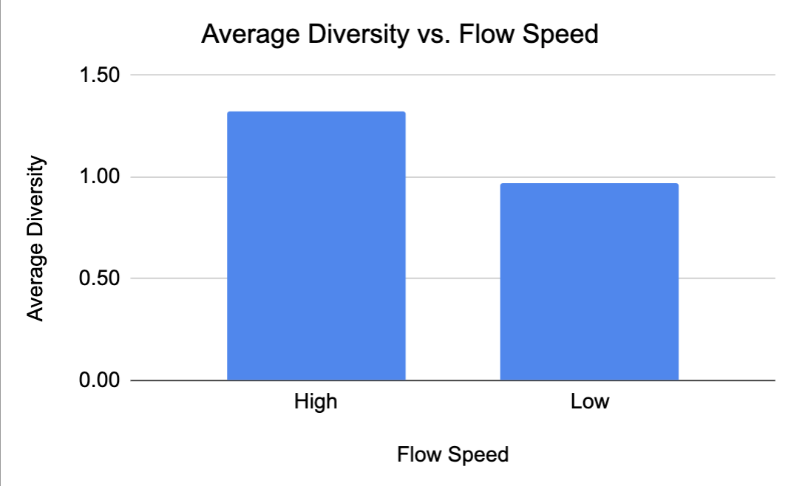
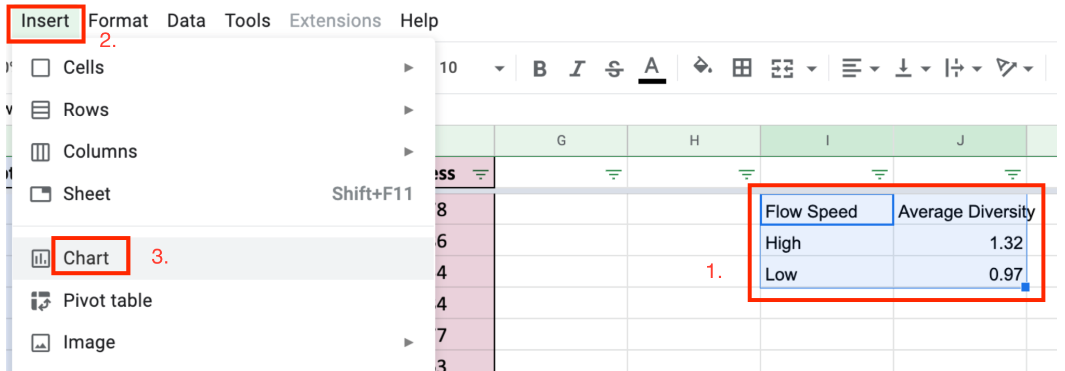
Step 4: Make a graph! Now that you have your dependent and independent variables chosen, select the appropriate sections of your data table and insert a chart.

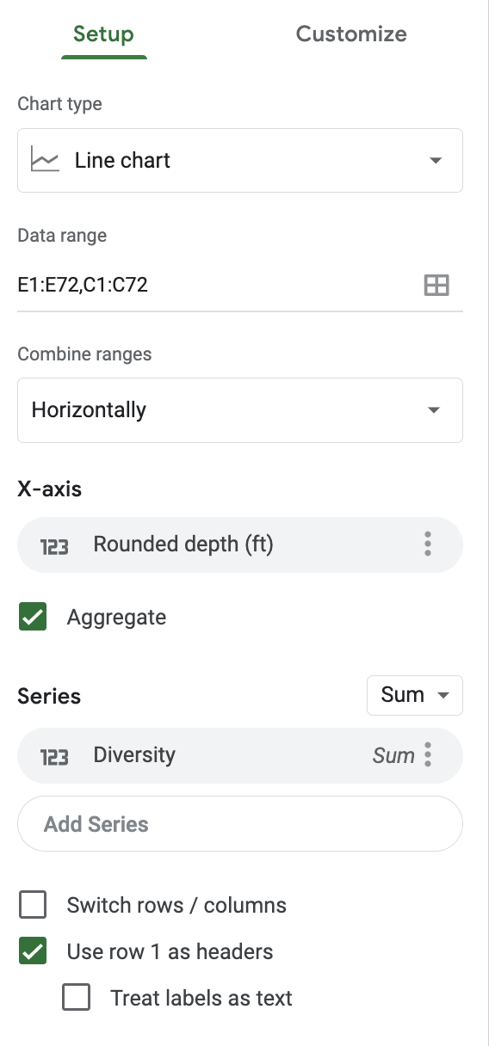
If you’re using whole columns of data, you’ll end up with something more like this. If you are having trouble, make sure your “Setup” panel looks like the one on the right.
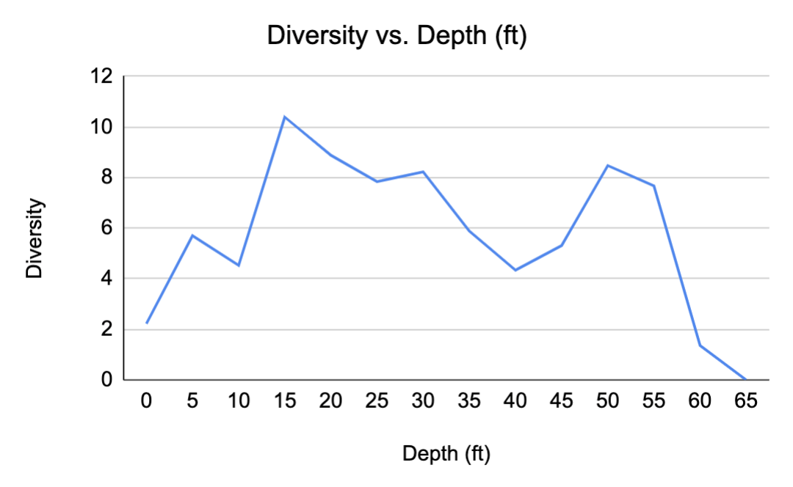

Step 5: Interpret your graph! You have now spent some time considering your question and the data you have available. Ideally you will be able to find the answer to your original question (from step 1) by examining your graph.
What do you notice? Are there clear differences or patterns?
Step 6: The final step is to tie it all together! Look back at your question from step 1 before answering the following.

In a sentence or two, summarize the result that your graph shows. This should be written as an answer to your question.

Does the result you found match your prediction?

What might explain the differences between what you expected and what you see here?

