Activity B: Analyze and Interpret

Kelp Forest Complexity

Analyzing data and interpreting graphs: Role of depth in algal communities

The understory of a kelp forest is made up of a diverse community of smaller algae. In areas with different amounts of light or water flow, these communities are different as a reflection of the different abiotic factors! Follow the instructions below to analyze your data and draw conclusions about the role of depth in algal communities.

Before starting, write and explain your prediction to the following question below:
How do you predict that algal species richness will change from 0ft to 60ft?

Instructions:
- For this activity, use the Analyze and interpret: Species richness and depth worksheet. You will need to make a copy of the file and save it to your own Google Drive account before continuing. Open up your new copy of the spreadsheet and make sure your data look like this to start:
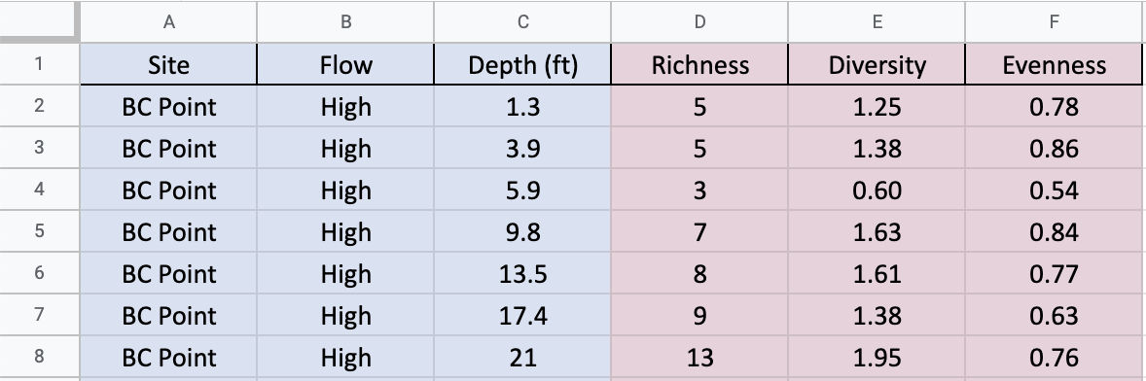
- Select all 6 columns by clicking on the A at the top of the “Site” column and dragging over to the F at the top of the “Evenness” column. Then, click on the Filter button in the toolbar. Your spreadsheet should now look like this:
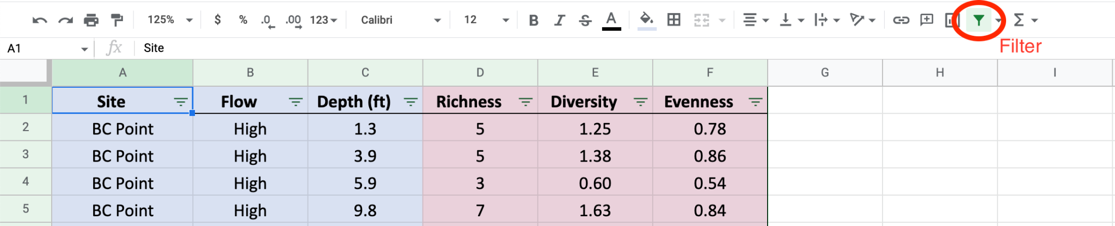

- Click on the three green arrows at the top of the “Depth” column to open a drop-down menu. From there, select “Sort A -> Z”
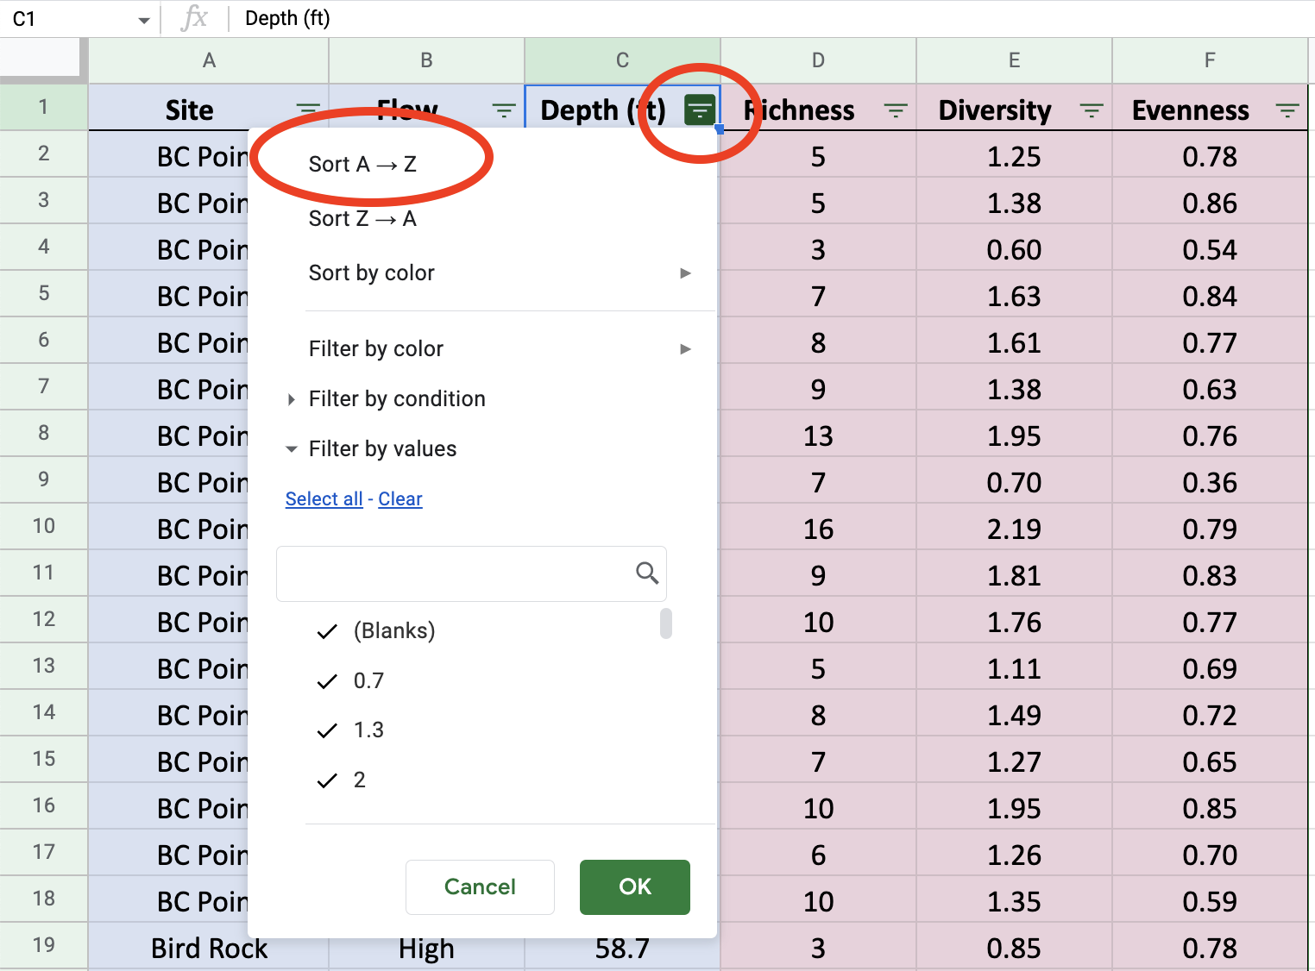
- Your data should now look like this. Double check with your teacher before continuing on to step 5.
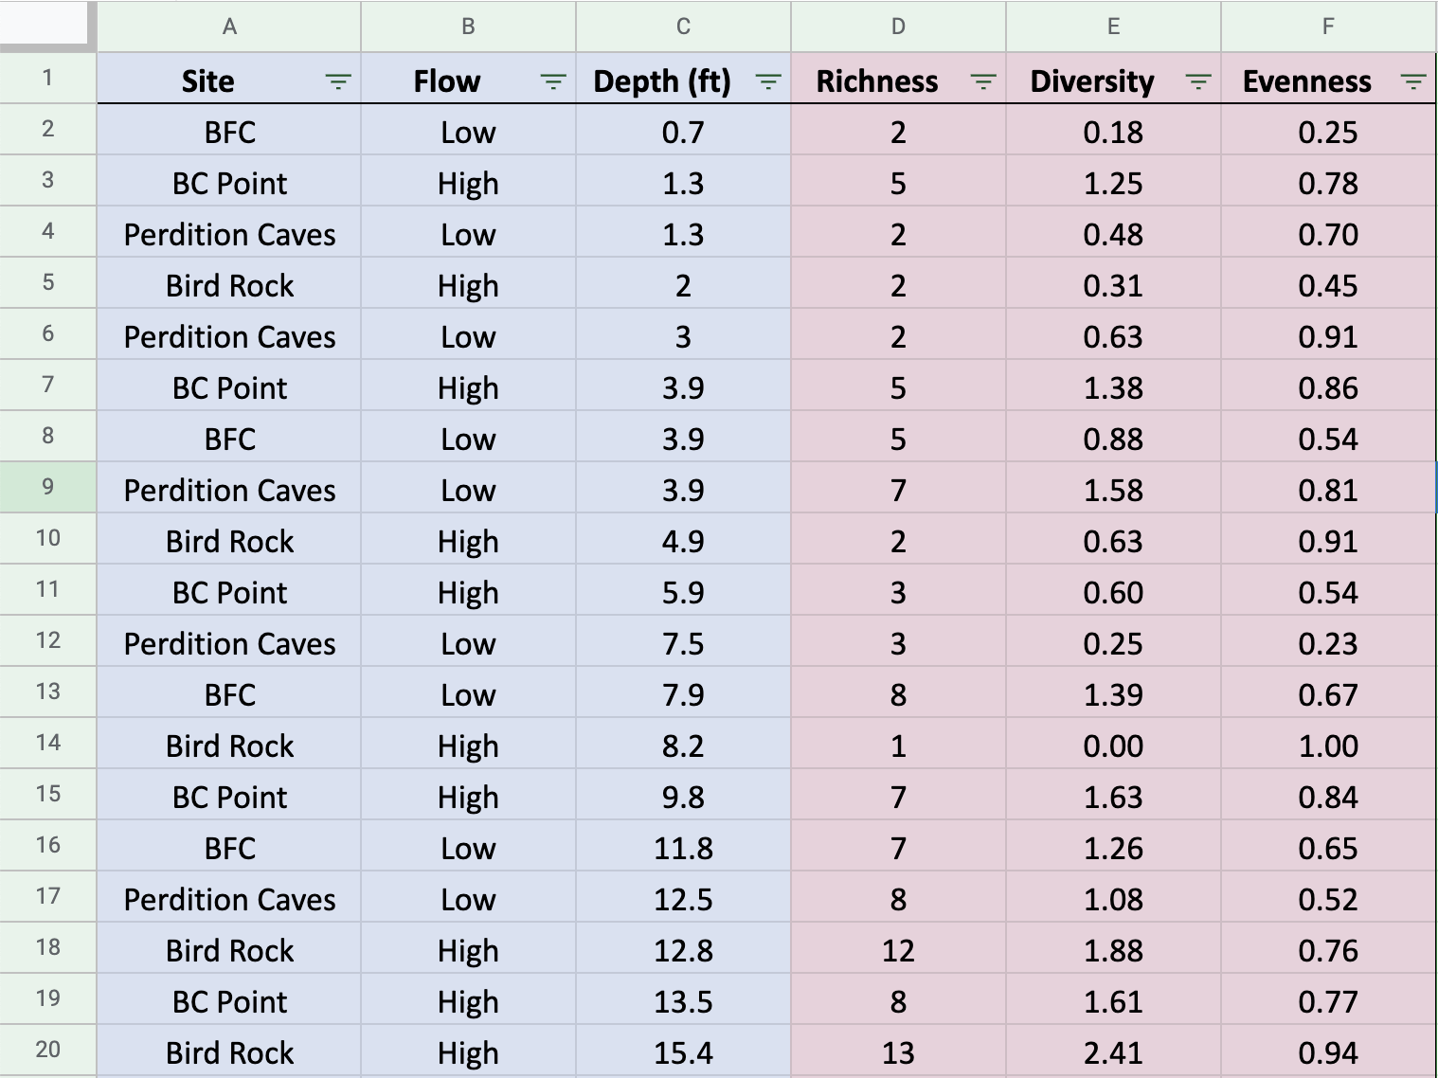

Now that we have prepared our data for analysis, let’s do some calculations!
Our first goal is to find the average species richness from 5 to 20 feet underwater.

- For easier use, click on View > Freeze > 1 Row so you can scroll down and still see the column names.
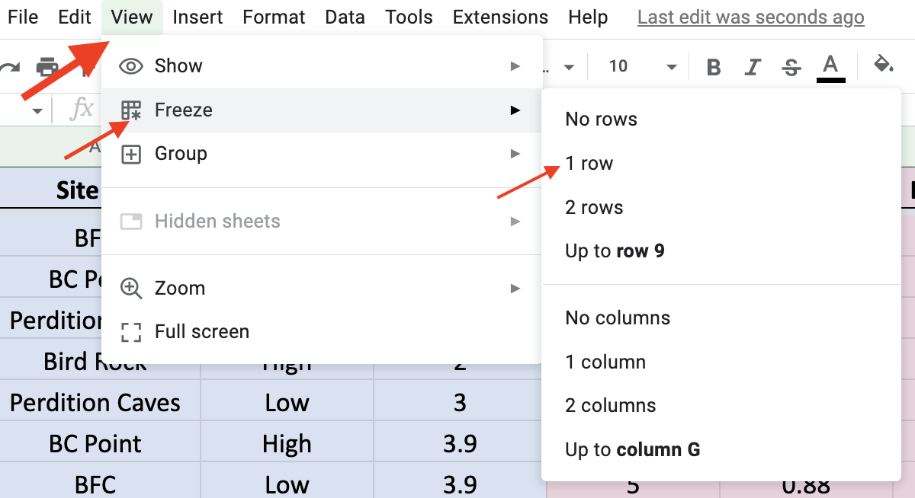
- It’s time to select our data! As a reminder, we want to answer the following question: What is the average species richness from 5 to 20 feet underwater?
To calculate this number, select an empty cell to the right of the data and enter the following formula: =AVERAGE(

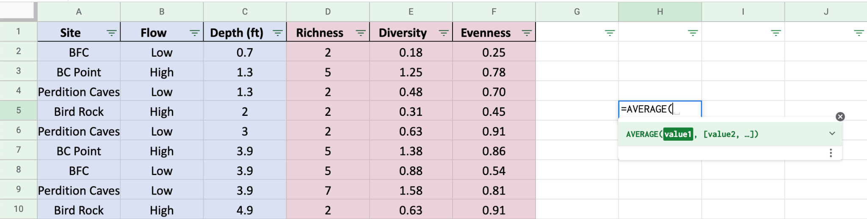
- Select the data that you want to average. In this case, select all of the values in the “Richness” column that have corresponding depths between 5 and 20ft. Press Enter to calculate the average. Do not delete this cell.
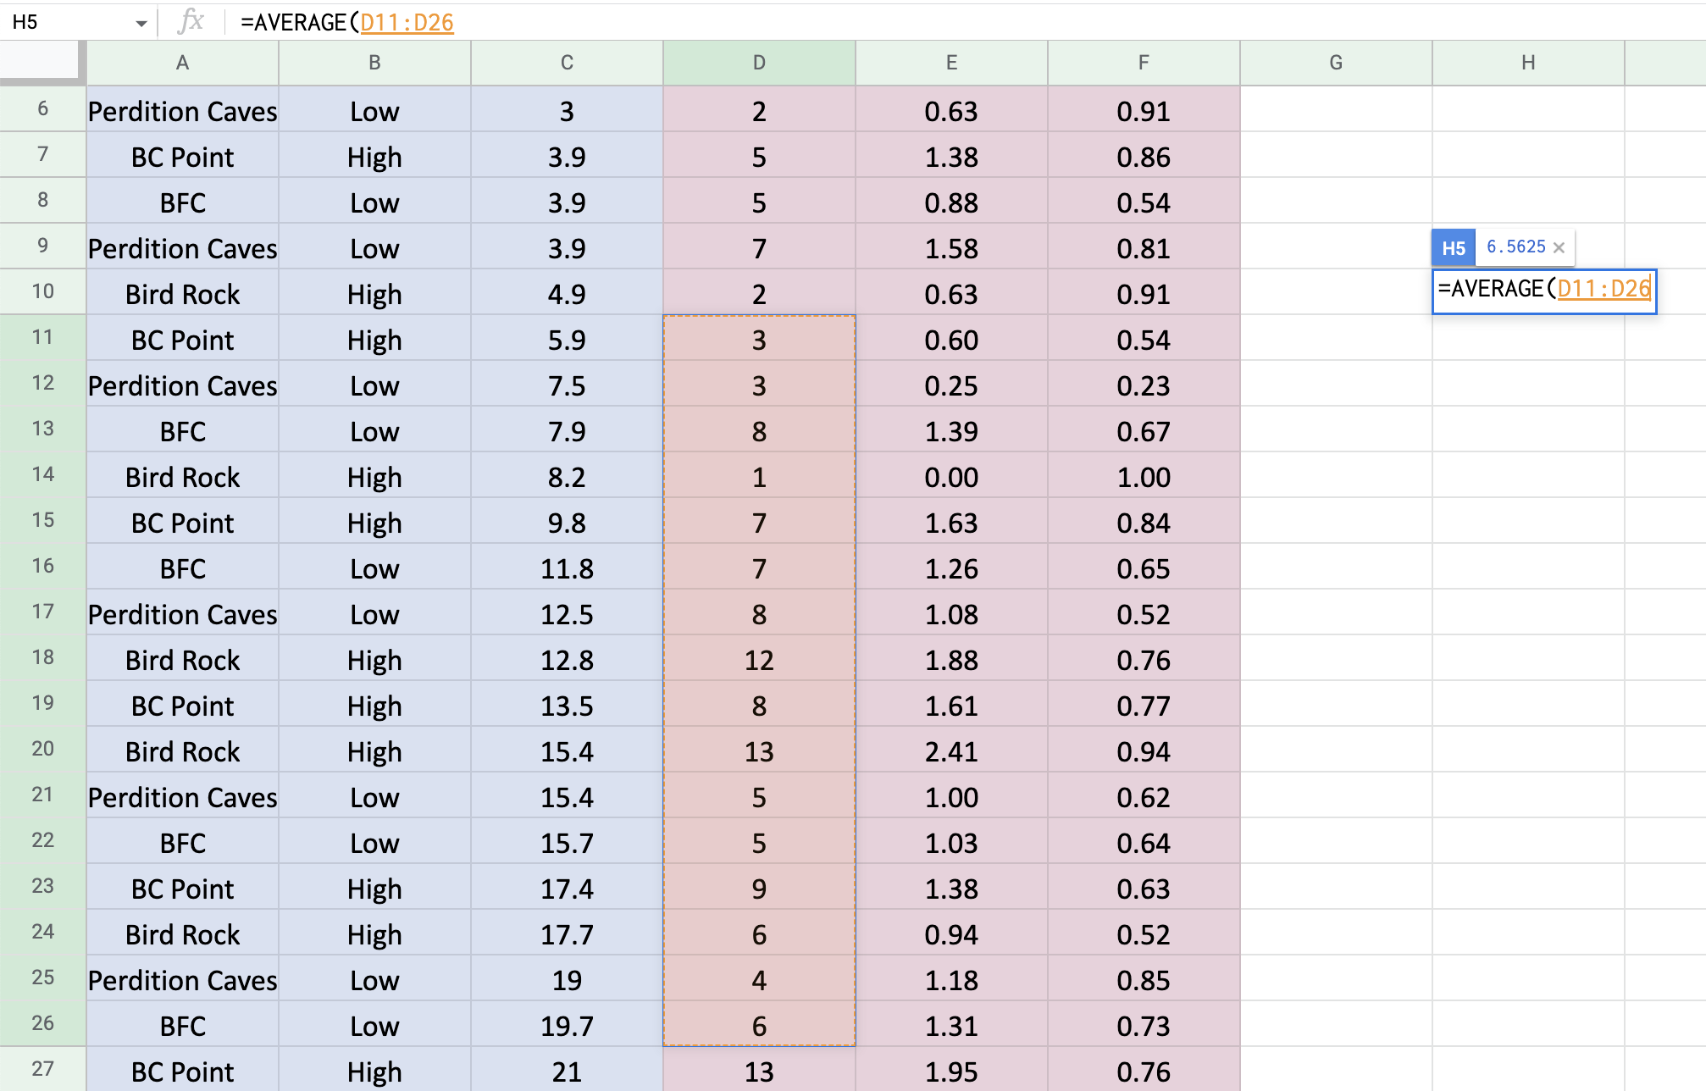
- Now that you have calculated the average species richness from 5-20ft, follow steps 6-7 again but now find the average species richness from 45-60ft. Do not delete this cell.

Use your data and notes from class to answer the following questions.

What is the average species richness from 5-15ft? _____________

What is the average species richness from 45-60ft? _____________

Go back to the first page and re-read your prediction. Do the results support your prediction? Explain why or why not.

What do you think is the most important abiotic factor that drives this pattern?

How does the abiotic factor you chose affect seaweed communities?

If you could dive to 100ft, would you expect the species richness to be higher or lower than at 60ft? Explain your reasoning.

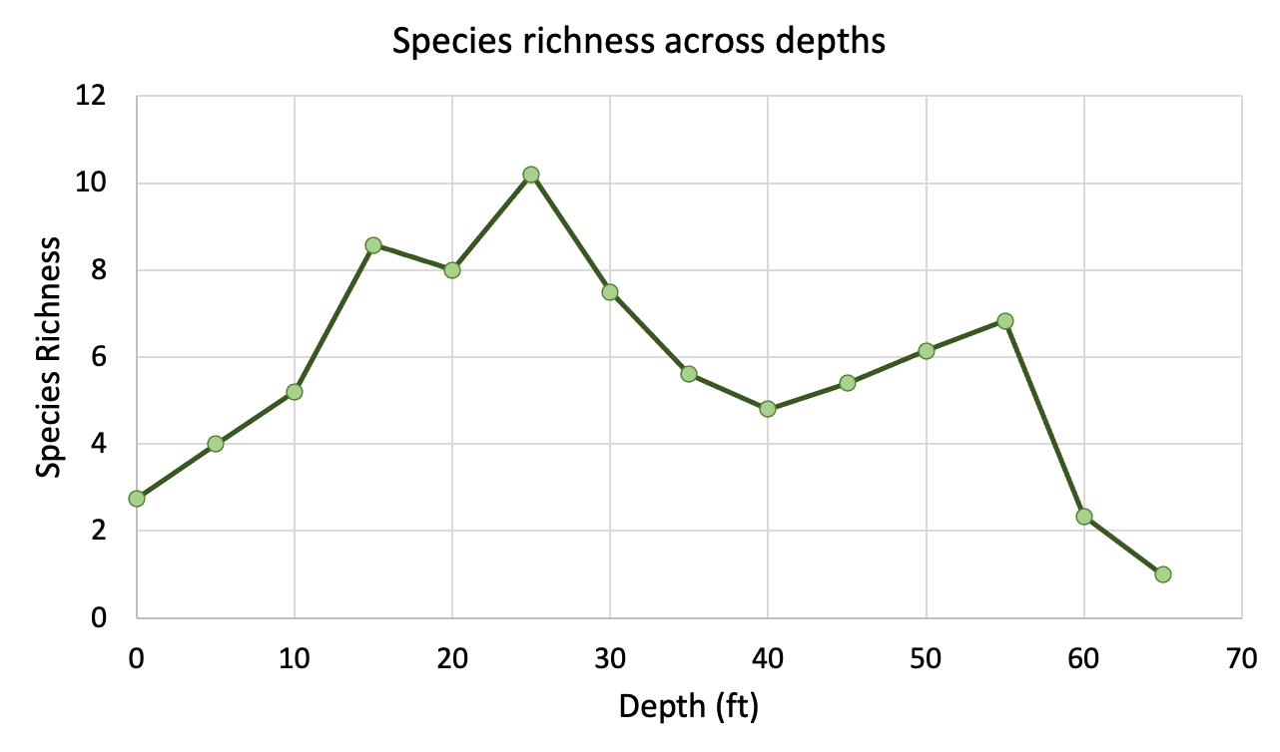

Use the graph above to answer the following questions.

Which depth has the highest species richness? __________

Which depths have the lowest species richness? a)_______ and b)________.

There are two different depth ranges that have a species richness of 4 or less. What do you think is the reason for such low species richness in each of those depths?

