Activity A: Interpreting Graphs

Kelp Forest Complexity

Interpreting graphs: Role of currents in algal community structure

The understory of a kelp forest is made up of a diverse community of smaller algae. In areas with different amounts of light or water flow, these communities are different as a reflection of the different abiotic factors. The following graphs represent the understory algal community at four different sites on Catalina Island.

Graph A shows the average biodiversity index and graph B shows the average species richness at each of our four sites. In addition, each site is labeled according to how “exposed” it is, or how fast the currents are in that area. Think about why this abiotic factor might influence seaweed communities!

Before you start:
- Briefly define biodiversity and species richness and explain how they are different.

- Do you think that biodiversity of algae will be higher in areas with faster currents or slower currents? Explain your answer.

- Do you think that there will be more species (higher species richness) in areas with faster currents or slower currents? Explain your answer.

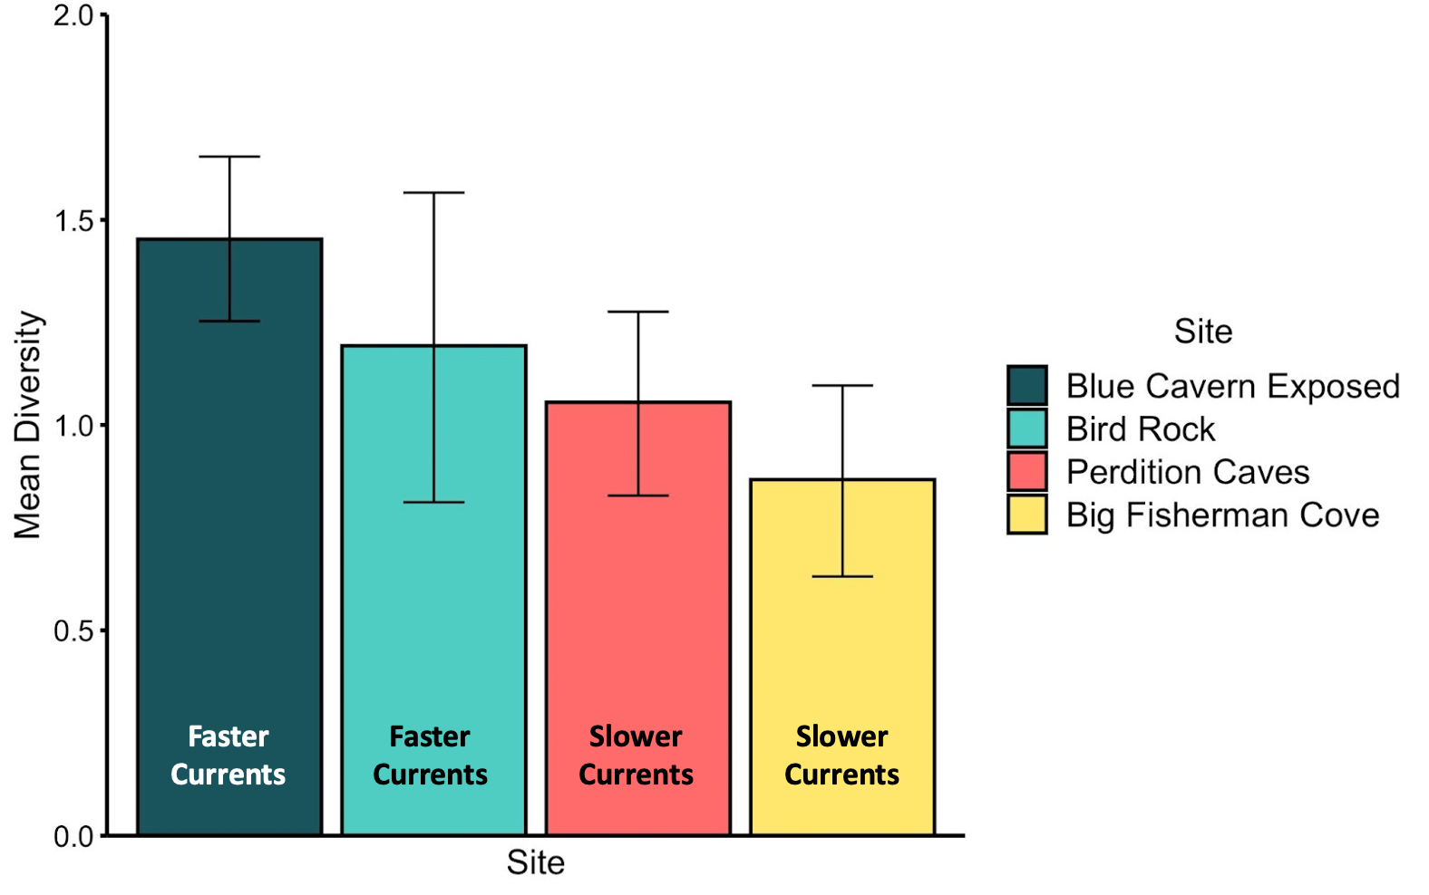
Graph A: Biodiversity

- Which site has the highest mean diversity? Which one has the lowest?

- Do you see any patterns between diversity and current speed?

Graph B: Species richness
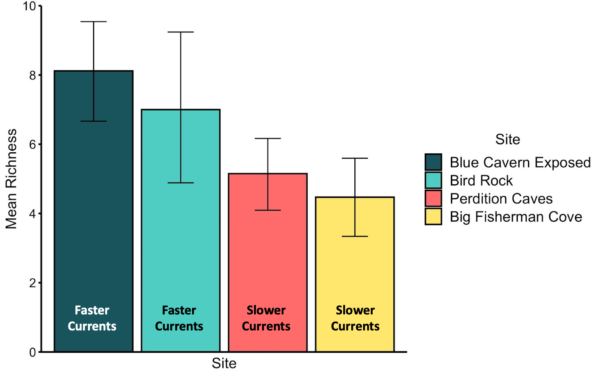
- Which site has the highest species richness? Which one has the lowest?

- Do you see any patterns between species richness and current speed?

Summary questions:
- Look back at your answers to questions 2 and 3. Were your predictions correct? Why or why not?

- Provide one explanation for why you think these patterns emerged. How do you think currents impact algal communities?

