Hybrid Beachgrass Student Workbook

Field Trip Edition

BEACHGRASS PROJECT

Background: Hybridization is defined as the breeding between two parents that are genetically dissimilar, producing a hybrid offspring. Some hybrid organisms are intentionally created by humans, such as the pluots or tangelos you may observe at the grocery store (Fig. 1). However, opportunities for accidental hybridization are increasing around the world because of climate change and species introductions by humans, which may cause species to overlap in their ranges that would not have otherwise. Hybridization between two species, called interspecific hybridization, has the potential to lead to more invasive offspring in plants.
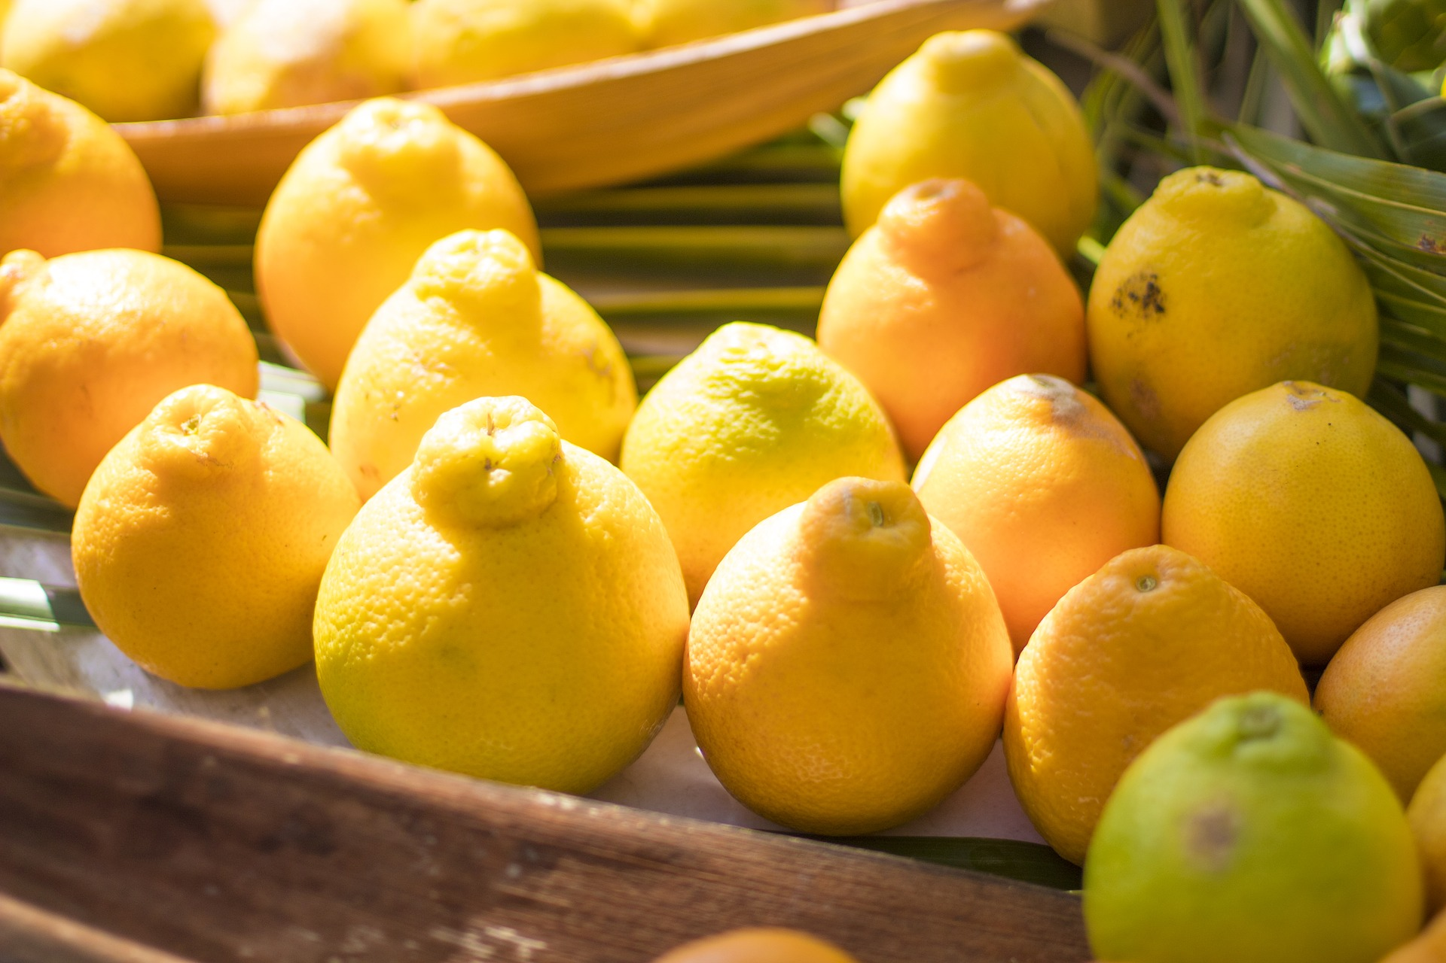

Fig. 1: Tangelo, hybrid of a tangerine and a grapefruit (Source: Image by Terry Cnudde from Pixabay)

On Pacific Northwest coastal dunes, a hybrid beachgrass was discovered in the last decade by researchers at Oregon State University. This beachgrass is the result of the unintentional breeding by its two parent species, European beachgrass (Ammophila arenaria) and American beachgrass (A. breviligulata). All of these beachgrasses were intentionally introduced to stabilize dunes, but also decrease habitat for some native species, posing complex tradeoffs. The hybrid was discovered because it had certain traits that were different from the other two beachgrass species. For instance, researchers noticed that the hybrid’s ligule, or the thin piece of tissue at the base of its leaves, was taller than one beachgrass parent but shorter than the other (Fig. 2).

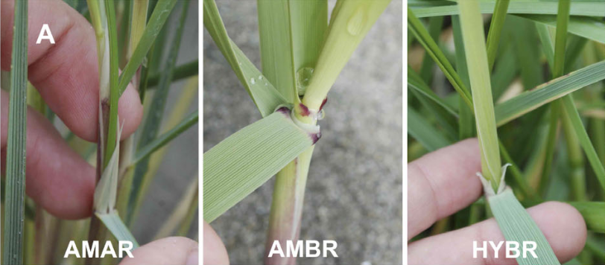
Fig. 2: Pictures of hybrid ligule (right) compared to its parents (left and center), Ammophila arenaria (AMAR) and A. breviligulata (AMBR). Source: Image from Mostow et al. (2021)

While the hybrid has several traits that are intermediate compared to its parent species, it displays others that exceed its parents. For instance, the hybrid grows taller than both of its parents, and more densely than one of its parents under field conditions. This phenomenon, in which hybrid organisms are more “fit” than their parents, is known as hybrid vigor, or heterosis. We will examine data later to determine if this is true for our set of beachgrasses.

Other research has found that beachgrasses with taller and denser stems are associated with more sand capture and taller dunes; therefore, the hybrid has the potential to form larger dunes that protect better against sea level rise and storms. However, the hybrid may continue to outcompete native dune species and drive their decline. This hybrid represents the ways that humans can influence their environment and how the environment then affects us, often in ways that are unexpected and rarely straightforward.

In this lesson, you will find beachgrass to observe, draw specimens, record observations, and identify different beachgrass species. In addition, you will also explore how plant species richness and plant communities change along the dune profile, or as you move from the beach to the back of the dune.

Activity option 1: Beachgrass observation

Directions: Use your observation skills to fill in information as we explore the grasses on the dunes. Find a stand of grasses to observe where you have room to quietly work.

Step 1: Draw your dune grass here, spending about 10-15 minutes to make detailed observations and notes about what you see.
Step 2: Find a flagged patch of the grasses. Write which color flag you chose: ___________
- Write down your observations - think about color, ligule length, leaf width and shape, density of the plant, and where you are geographically.
- Refer back to the Field Guide or the Beachgrass ID Guide to identify the beachgrass taxa through its ligule.
Which beachgrass taxa have you identified? ______________________________
Step 3: Find another patch of grasses marked with a different color flag. Write which color flag you chose: ___________
- Write down your observations - think about color, ligule length, leaf width and shape, density of the plant, and where you are geographically.
- Refer back to the Field Guide or the Beachgrass ID Guide to identify the beachgrass taxa through its ligule.
Which beachgrass taxa have you identified? ______________________________

Activity option 2: Transect and quadrat measurements
Step 1: Lay out a transect tape.
- This will require at least two people, one at each end of the transect tape. One person can walk the transect tape over the dune in the shore-perpendicular direction, and the transect should be able to reach as far back as the dune heel, if desired.
Step 2: Collect data on plant density, cover, and species composition within quadrats.
- Each group will be assigned a quadrat (0.25 m²) to place at a certain position along the transect tape (check with your teacher if uncertain).
- Make sure all the vegetation that falls within the quadrat isn’t trapped under the quadrat corners by separating inside vs. outside vegetation with your hands.
- Record data on at least one of the following variables:
  - How many different plant species can you count (even if you can’t identify non-beachgrass plants)? Don’t forget to consult the Field Guide for several common plant species.
  - What is the percent cover of each different species? Estimate this by looking at the quadrat from above and rating the cover of each species from 0-100%.
  - How many stems of each dune grass taxa can you count? Stem density is often a more accurate measure of coverage. Feel around at the base of the sand to determine how many stems are present.
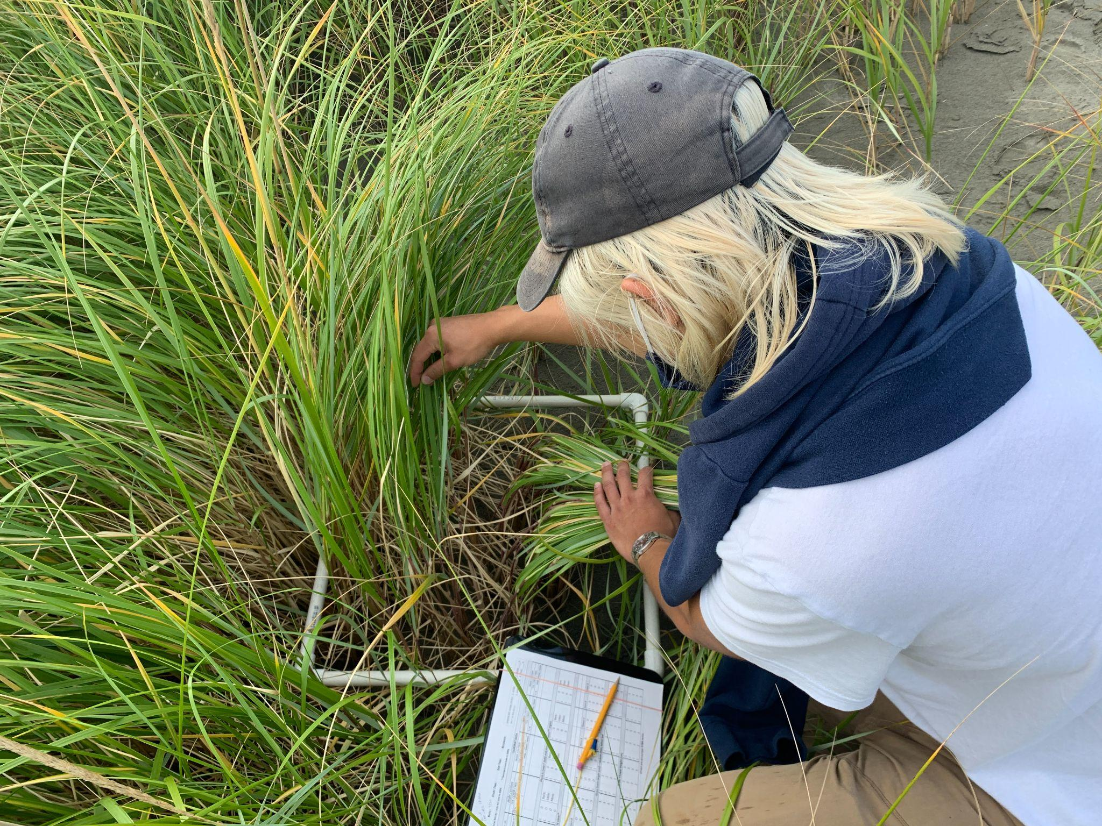
Fig. 3: A researcher counts the stem density of the hybrid beachgrass within a 0.25 m² quadrat.

Activity 3: Dune activity questions and hybrid beachgrass implications
Step 1: Answer this series of questions.
- Where did the class observe the greatest species richness along the transect? The greatest dune grass stem density? Write a potential hypothesis for these observed patterns.

- How do you think the hybrid may affect other dune services besides dune shape, such as species conservation?
- Would you consider the hybrid beachgrass native or non-native? Why?
- How about native species that expand their range due to climate change - are they native or non-native, and why?
- Do you think the hybrid should be encouraged to spread, or controlled and removed? Please explain.

