Hybrid Beachgrass Student Workbook

Class Edition

BEACHGRASS PROJECT

Background: Hybridization is defined as the breeding between two parents that are genetically dissimilar, producing a hybrid offspring. Some hybrid organisms are intentionally created by humans, such as the pluots or tangelos you may observe at the grocery store (Fig. 1). However, opportunities for accidental hybridization are increasing around the world because of climate change and species introductions by humans, which may cause species to overlap in their ranges that would not have otherwise. Hybridization between two species, called interspecific hybridization, has the potential to lead to more invasive offspring in plants.
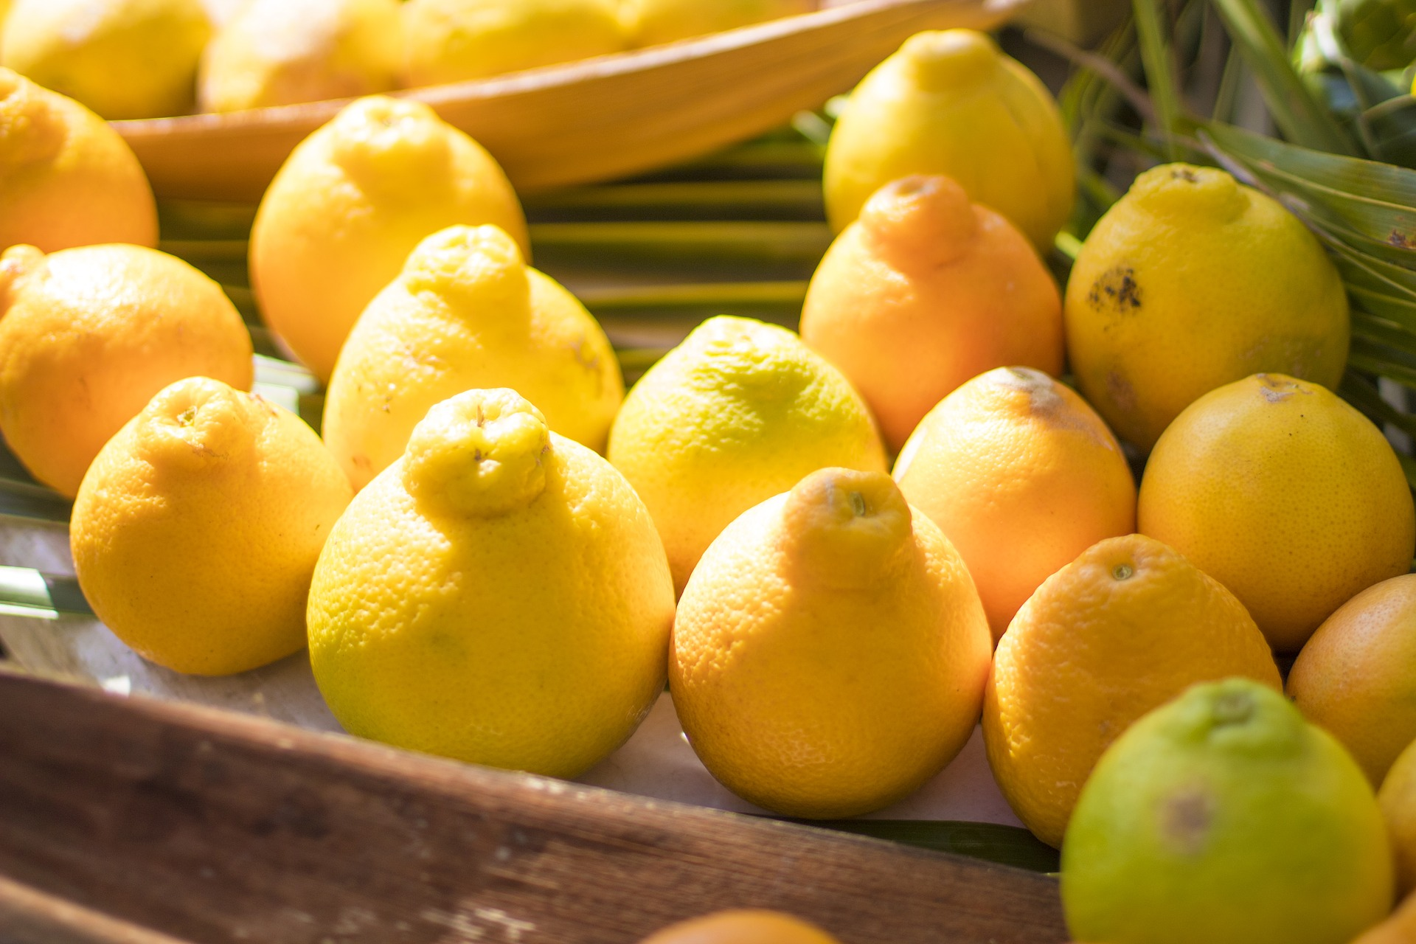

Fig. 1: Tangelo, hybrid of a tangerine and a grapefruit (Source: Image by Terry Cnudde from Pixabay)

On Pacific Northwest coastal dunes, a hybrid beachgrass was discovered in the last decade by researchers at Oregon State University. This beachgrass is the result of the unintentional breeding by its two parent species, European beachgrass (Ammophila arenaria) and American beachgrass (A. breviligulata). All of these beachgrasses were intentionally introduced to stabilize dunes, but also decrease habitat for some native species, posing complex tradeoffs. The hybrid was discovered because it had certain traits that were different from the other two beachgrass species. For instance, researchers noticed that the hybrid’s ligule, or the thin piece of tissue at the base of its leaves, was taller than one beachgrass parent but shorter than the other (Fig. 2).

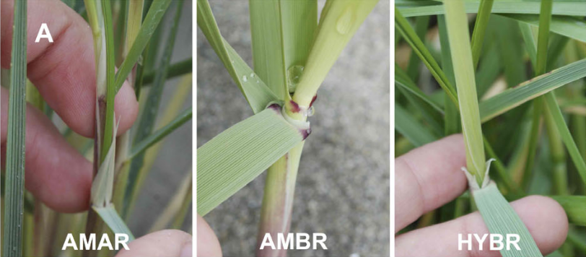
Fig. 2: Pictures of hybrid ligule (right) compared to its parents (left and center), Ammophila arenaria (AMAR) and A. breviligulata (AMBR). (Source: Image from Mostow et al. (2021))

While the hybrid has several traits that are intermediate compared to its parent species, it displays others that exceed its parents. For instance, the hybrid grows taller than both of its parents, and more densely than one of its parents under field conditions. This phenomenon, in which hybrid organisms are more “fit” than their parents, is known as hybrid vigor, or heterosis.

Other research has found that beachgrasses with taller and denser stems are associated with more sand capture and taller dunes; therefore, the hybrid has the potential to form larger dunes that protect better against sea level rise and storms. However, the hybrid may continue to outcompete native dune species and drive their decline. This hybrid represents the ways that humans can influence their environment and how the environment then affects us, often in ways that are unexpected and rarely straightforward.

In this lesson, you will use beachgrass data collected by OSU researchers to examine if the hybrid displays hybrid vigor and the implications its traits may have for dune ecosystems.

Step 1: Below is a bar graph of the stem density of the hybrid beachgrass compared to its parents on coastal dunes.
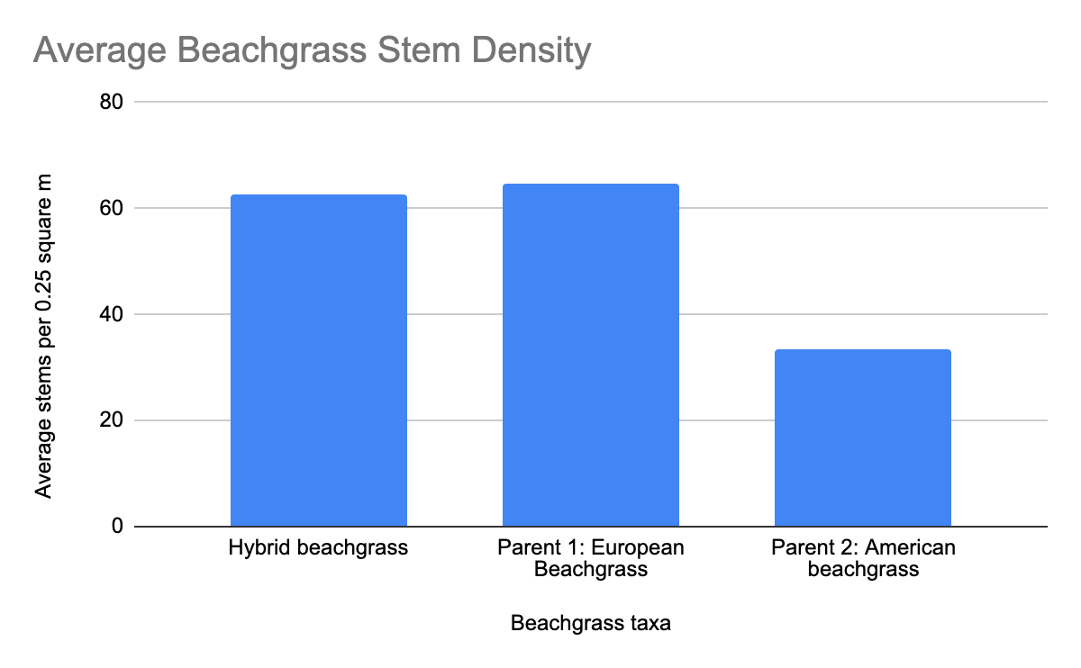
Using this above graph as a guide, use the Beachgrass Traits Data to create a bar graph of the average stem height of the hybrid beachgrass compared to its parent species. Use these instructions:
- Calculate averages for the stem height of each beachgrass taxa using the shaded cells provided.
  - In cell E2 for the hybrid beachgrass average, type in the formula “= AVERAGE ()”. Within the parentheses, highlight the stem height data associated with the hybrid beachgrass.
  - Repeat step a. for the next two beachgrasses.
- Highlight the shaded cells with your cursor. Click Insert then select Chart. A bar chart will appear.
- Add an appropriate title, and x- and y-axes (with units).
- Copy and paste your graph below.
Step 2: Answer this series of questions about the hybrid beachgrass.
- How do stem height and density of the hybrid beachgrass compare to its parent beachgrasses in the two above graphs? How might this affect the amount of sand the hybrid beachgrass can capture and the shape of dunes it may produce?
- How do you think the hybrid may affect other dune services besides dune shape, such as species conservation?
- Would you consider the hybrid beachgrass native or non-native? Why?
- How about native species that expand their range due to climate change - are they native or non-native, and why?
- Do you think the hybrid should be encouraged to spread, or controlled and removed? Please explain.

