Dune profile data analysis - Student worksheet

BEACHGRASS PROJECT

Background: One hundred years ago, Oregon dunes were shifting environments and sparsely vegetated (think of the desert planet in the movie Dune!) with a high diversity of native plant species. Then, beginning around the 20th century, two invasive species, European and American beachgrass (Ammophila arenaria and A. breviligulata, respectively), were introduced intentionally to the Pacific Northwest coast (Fig. 1). These two grasses are ecosystem engineers, meaning that they are able to alter or “engineer” the environment around them. They do this by building dunes through feedback between beachgrass growth and the accumulation of sand around them.

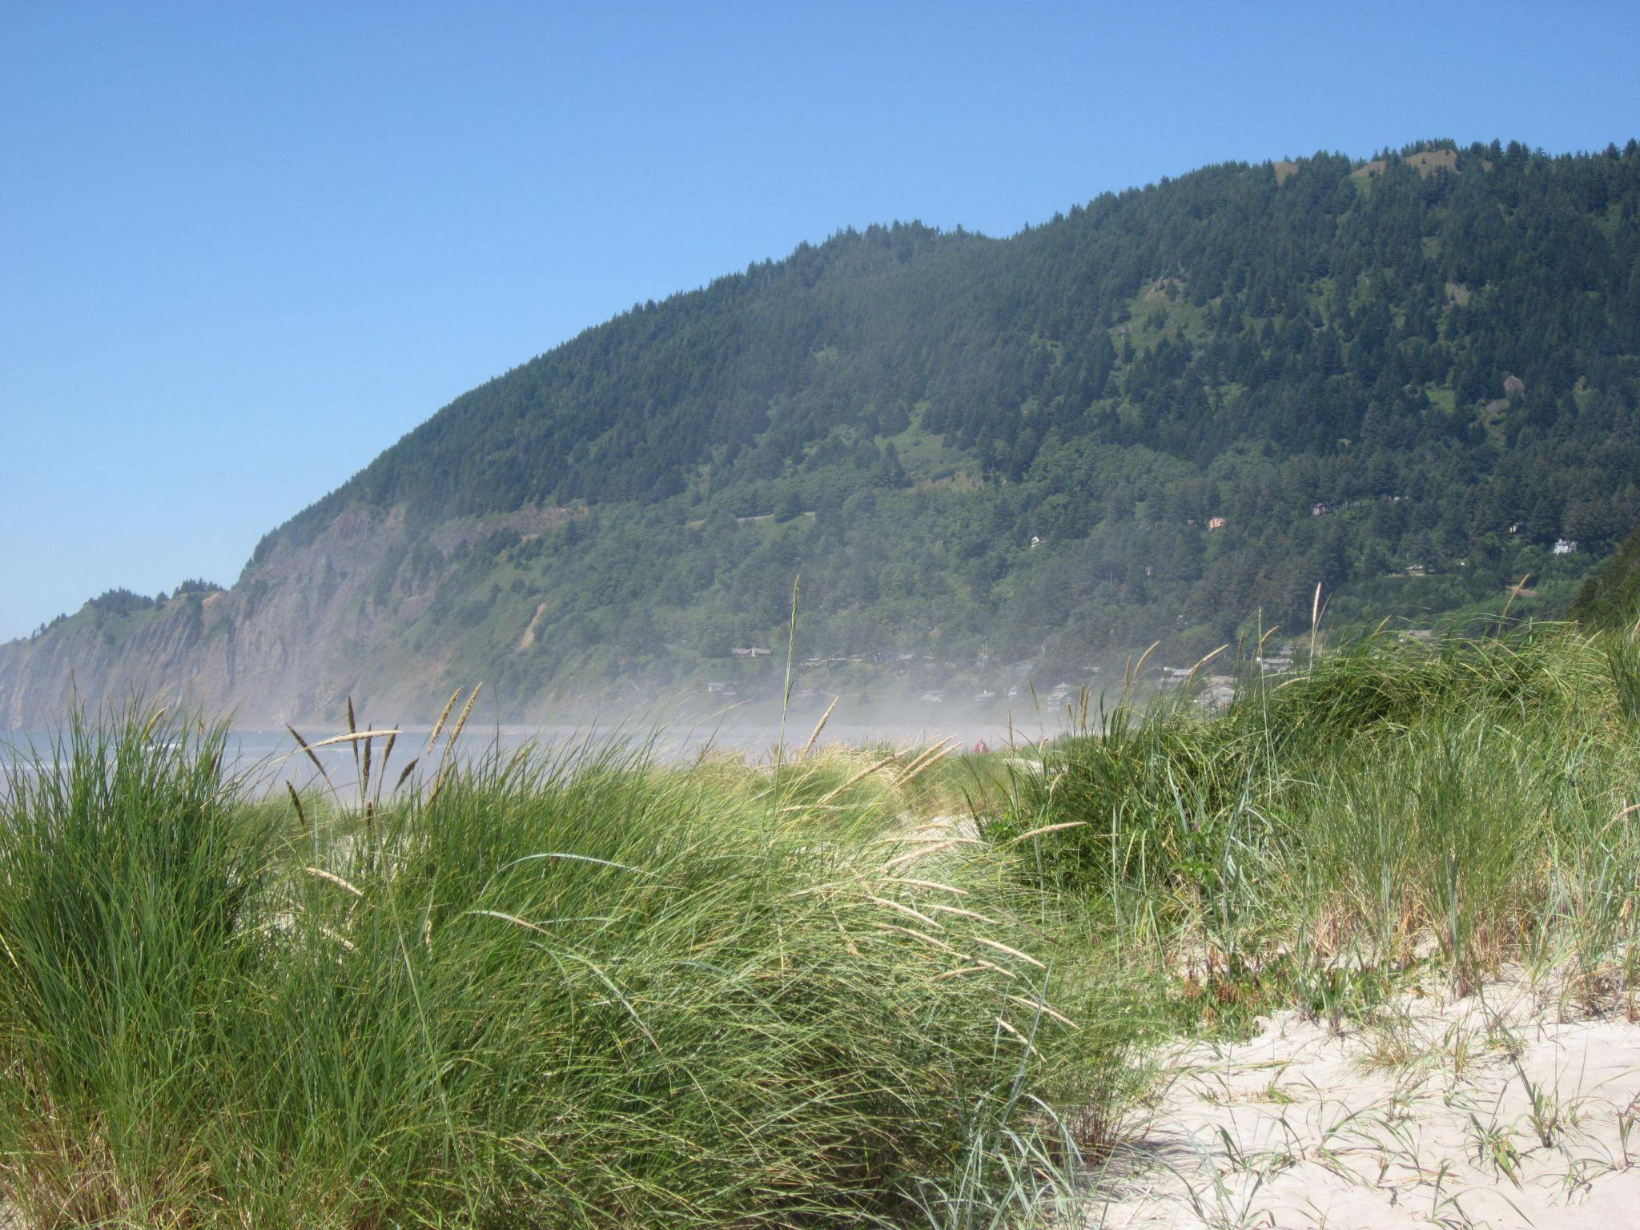
Fig. 1: Dunes and beachgrass at Manzanita Beach, Oregon. Source: “Manzanita Beach - Oregon” by Doug Kerr, licensed under CC BY-SA 2.0.

These two invasive grasses were purposefully introduced to stabilize the shifting sand and build large dunes - some over 30 feet tall. These dunes help protect against sea level rise and extreme storms, which are increasing due to climate change - and have increased protection for communities that are situated near the Oregon coast. However, introduced beachgrasses have also rapidly colonized coastal dunes and lead to declines in some native species, such as the Western snowy plover. Therefore, these beachgrasses pose tradeoffs in ecosystem services, which are the benefits humans get from their environment.
These beachgrasses and dunes are managed for a variety of uses and reasons, including native plant conservation, recreation, coastal protection from storms and sea level rise, and aesthetics. One such management activity is dune grading, in which all vegetation is removed and a dune is essentially flattened. Since beachgrasses build dunes that may obstruct views of the ocean for houses along the coastline, homeowners may pay to remove the dune to improve viewsheds, or their ability to see the beach and ocean (Fig. 2). However, it is Oregon law that graded dunes must be immediately replanted with beachgrass, in order to improve sand stabilization and coastal protection.

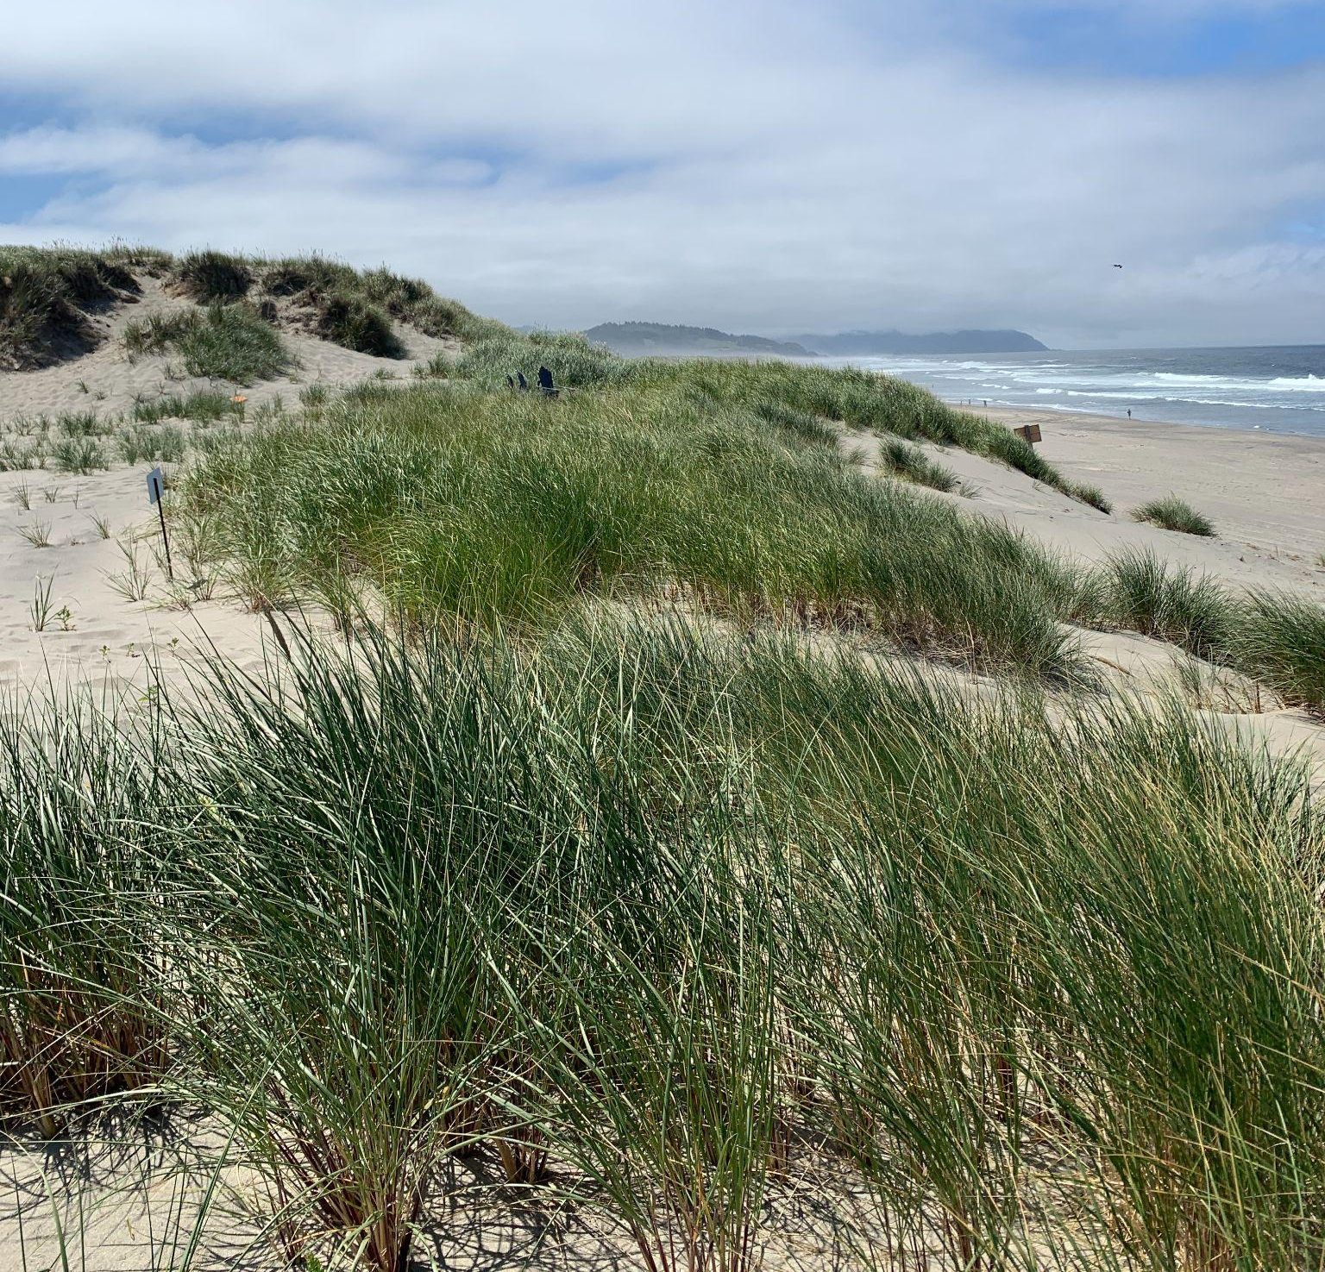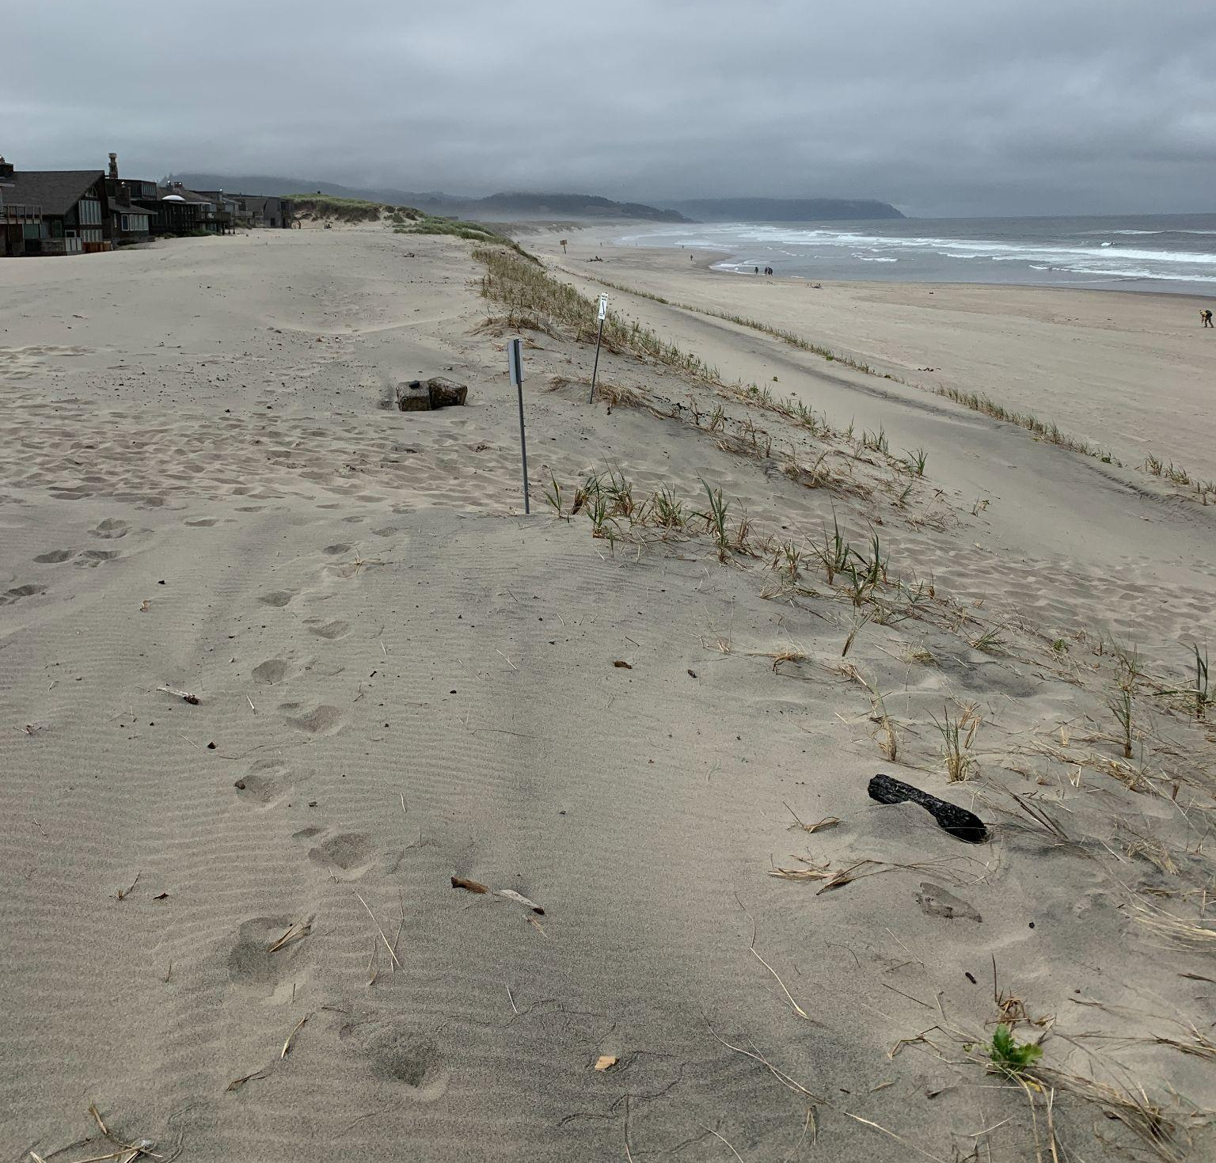
Fig. 2: Unmanaged and vegetated dune (left) vs. dune that has been graded and recently re-planted with beachgrasses in front of homes (right), both at Pacific City.

Below, we showcase survey data from two different dune areas: one that has vegetation on it, and another that has been graded and recently replanted to improve viewshed access.

Directions: Look over the Dune profile data and use it, coupled with the information in this worksheet, to complete the activity and answer the following questions.
Step 1: Create a line graph to represent each dune profile - one for the vegetated, and another for the unvegetated dune. Follow these instructions to make one on your own Excel or Google Sheet copy:
- On the spreadsheet, highlight all cells with data from the unvegetated dune (columns A and B).
- Click Insert then select Chart. A line chart will appear.
- We will then need to re-format the lines that appear. Under Series, click the three dots next to Distance along transect (m) and select Remove. Height should now be the only Series remaining.
- Under X-axis, click Add X-axis, and select the first option, Distance along transect (m). The line on the graph should now be correctly formatted.
- Add an appropriate title, and x- and y-axes (with units).
- Repeat steps 1A - 1E, but using columns C and D with data from the vegetated dune.
- Copy and paste the two graphs below.
Step 2: Think about how these two dunes are different (beyond their shape). What is the purpose of the dune being graded or ungraded? Who is using this, or who does it benefit? What is the effect on the ecosystem (such as other plants and animals)? Write a paragraph of 5-7 sentences below to address these questions, citing the data to support your conclusions.

Step 3: In your own words, how do plants influence dune shape? What would a dune look like if it was dominated by a short, small plant species vs. a tall, dense beachgrass?
Sources
Dune profile data were collected at Pacific City, Oregon by Carly Ringer and Hieu Ly with the College of Earth, Ocean and Atmospheric Sciences at Oregon State University in March 2022.

